Machine Learning Engineering for Production (MLOps) Specialization

by DeepLearning.AI



[Course Site](https://www.coursera.org/learn/introduction-to-machine-learning-in-production/home/welcome)

Made By: [Matias Borghi](https://mattborghi.github.io/)

Table of Contents

**Course #1 Introduction to Machine Learning in Production** **2**

**Week 1: Overview of the ML Lifecycle and Deployment** **4**

The Machine Learning Project Lifecycle 4

Deployment 7

**Week 1 Optional References** **15**

Week 1: Overview of the ML Lifecycle and Deployment 15

**Week 2: Select and Train a Model** **16**

Selecting and Training a Model 16

**Why low average error isn't good enough** **18**

Error analysis and performance auditing 22

**Performance auditing** **27**

Data iteration 28

**A useful picture of data augmentation** **29**

**Week 2 Optional References** **34**

Week 2: Select and Train Model 34

**Week 3: Data Definition and Baseline** **35**

Define Data and Establish Baseline 35

Why is data definition hard? 35

More label ambiguity examples 36

Major types of data problems 38

Small data and label consistency 40

Improving label consistency 42

Human level performance (HLP) 43

Raising HLP 45

Label and Organize Data 46

Obtaining data 46

Data pipeline 48

Meta-data, data provenance and lineage 49

Balanced train/dev/test splits 51

Scoping (optional) 51

What is scoping? 51

Scoping process 52

Diligence on feasibility and value 53

Diligence on value 55

Milestones and resourcing 56

Week 3 Optional References 57

Week 3: Data Definition and Baseline 57

References 58

Introduction to Machine Learning in Production 58

# Course #1 Introduction to Machine Learning in Production

**Week 1: Overview of the ML Lifecycle and Deployment**

**This week covers a quick introduction to machine learning production systems focusing on their requirements and challenges. Next, the week focuses on deploying production systems and what is needed to do so robustly while facing constantly changing data.**

**Learning Objectives**

* **Identify the key components of the ML Lifecycle.**
* **Define “concept drift” as it relates to ML projects.**
* **Differentiate between shadow, canary, and blue-green deployment scenarios in the context of varying degrees of automation.**
* **Compare and contrast the ML modeling iterative cycle with the cycle for deployment of ML products.**
* **List the typical metrics you might track to monitor concept drift.**

**Week 2: Select and Train a Model**

**This week is about model strategies and key challenges in model development. It covers error analysis and strategies to work with different data types. It also addresses how to cope with class imbalance and highly skewed data sets.**

**Learning Objectives**

* **Identify the key challenges in model development.**
* **Describe how performance on a small set of disproportionately important examples may be more crucial than performance on the majority of examples.**
* **Explain how rare classes in your training data can affect performance.**
* **Define three ways of establishing a baseline for your performance.**
* **Define structured vs. unstructured data.**
* **Identify when to consider deployment constraints when choosing a model.**
* **List the steps involved in getting started with ML modeling.**
* **Describe the iterative process for error analysis.**
* **Identify the key factors in deciding what to prioritize when working to improve model accuracy.**
* **Describe methods you might use for data augmentation given audio data vs. image data.**
* **Explain the problems you can have training on a highly skewed dataset.**
* **Identify a use case in which adding more data to your training dataset could actually hurt performance.**
* **Describe the key components of experiment tracking.**

**Week 3: Data Definition and Baseline**

**This week is all about working with different data types and ensuring label consistency for classification problems. This leads to establishing a performance baseline for your model and discussing strategies to improve it given your time and resources constraints.**

**Learning Objectives**

* **List the questions you need to answer in the process of data definition.**
* **Compare and contrast the types of data problems you need to solve for structured vs. unstructured and big vs. small data.**
* **Explain why label consistency is important and how you can improve it**
* **Explain why beating human level performance is not always indicative of success of an ML model.**
* **Make a case for improving human level performance rather than beating it.**
* **Identify how much training data you should gather given time and resource constraints.**
* **Describe the key steps in a data pipeline.**
* **Compare and contrast the proof of concept vs. production phases on an ML project.**
* **Explain the importance of keeping track of data provenance and lineage.**

## 

## Week 1: Overview of the ML Lifecycle and Deployment

### **The Machine Learning Project Lifecycle**

Just because you've trained a learning algorithm that does well on your test set, which is to be celebrated. It's great when you do well when you hold a test set. Unfortunately reaching that milestone doesn't mean you're done. There can still be quite a lot of work and challenges ahead to get a valuable production deployment running.

For example, let's say your training set has images that look like this. There's a good phone on the left, the one in the middle, it has a big scratch across it and you've trained your learning algorithm to recognize that things like this on the left are okay. Meaning that there are no defects and maybe draw bounding boxes around scratches or other defects that finds and films. When you deploy it in the factory, you may find that the real life production deployment gives you back images like this much darker ones. Because the lighting factory, because the lighting conditions in the factory have changed for some reason compared to the time when the training set was collected. This problem is sometimes called concept drift or data drift.

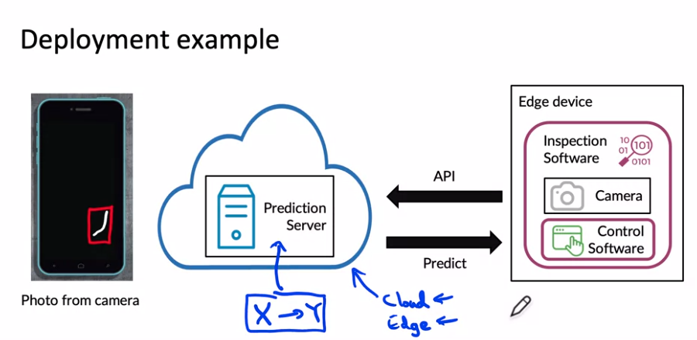

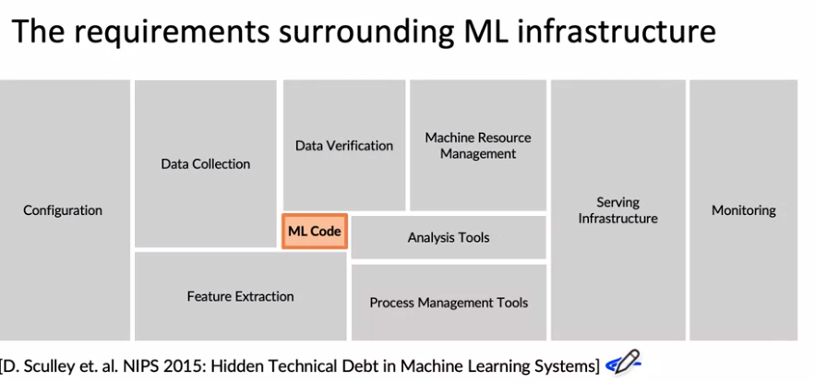

Beyond the machine learning codes there are also many components, especially components for managing the data, such as data collection, data verification, feature extraction.

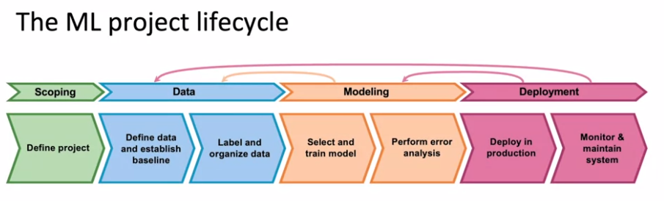

After having chosen the project, you then have to collect data or acquire the data you need for your algorithm.

Now that the system is deployed and is running on live data, and feeding that back into your dataset to then potentially update your data, retrain the model, and so on until you can put an updated model into deployment.

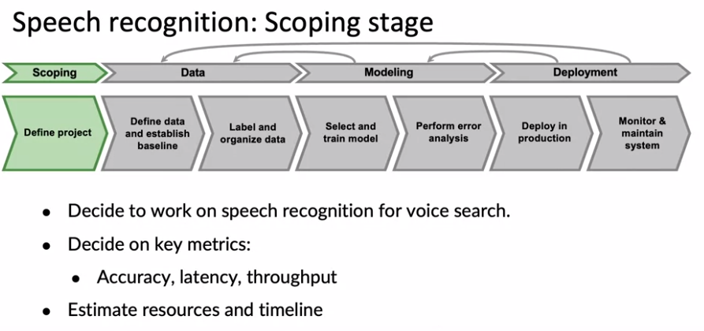

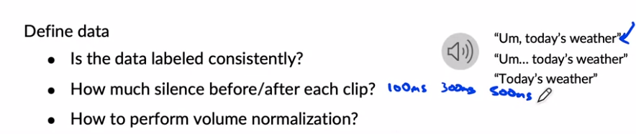

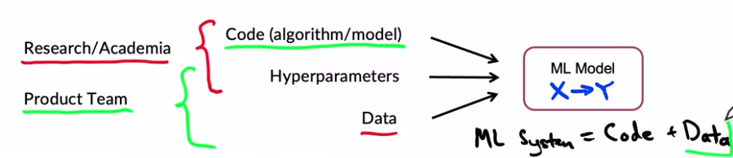

A lot of research work or academic work you tend to hold the data fixed and vary the code and may have varied hyper parameters in order to try to get good performance.

In contrast, for a lot of product teams, if your main goal is to just build and deploy a working, valuable machine learning system, it can be even more effective to hold the code fixed and to instead focus on optimizing the data and maybe the hyper parameters. In order to get a high performing model, A machine learning system includes both codes and data and also hyper parameters that may be a bit easier to optimize than the code or data. And rather than taking a model centric view of trying to optimize the code to your fixed data set for many problems, you can use an open source implementation of something you download from Github and instead just focus on optimizing the data.

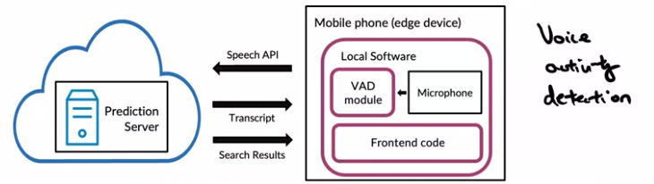

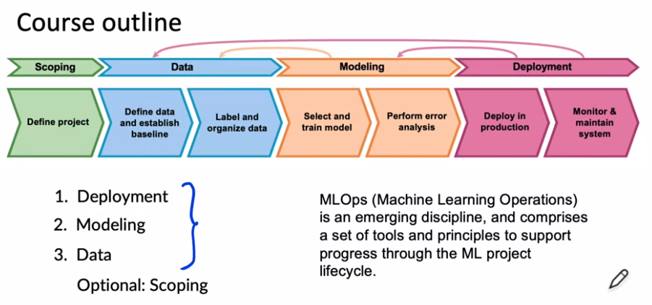

### **Deployment**

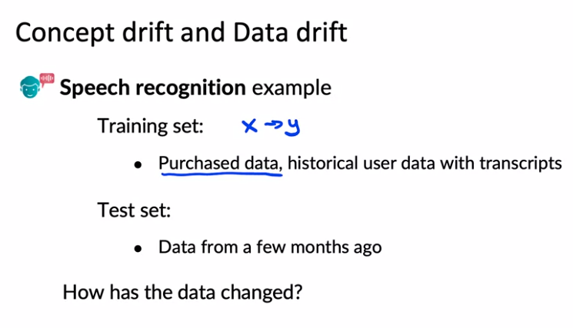

Changed: New language/new phone. Gradual change/ Sudden change. Fraud systems failed after covid because people changed their shopping patterns.

Another example of Concept drift, let's say that x is the size of a house, and y is the price of a house, because you're trying to estimate housing prices. If because of inflation or changes in the market, houses may become more expensive over time. The same size house will end up with a higher price. That would be Concept drift. Maybe the size of houses haven't changed, but the price of a given house changes. Whereas data drift would be if, say, people start building larger houses, or start building smaller houses and thus the input distribution of the sizes of houses actually changes over time.

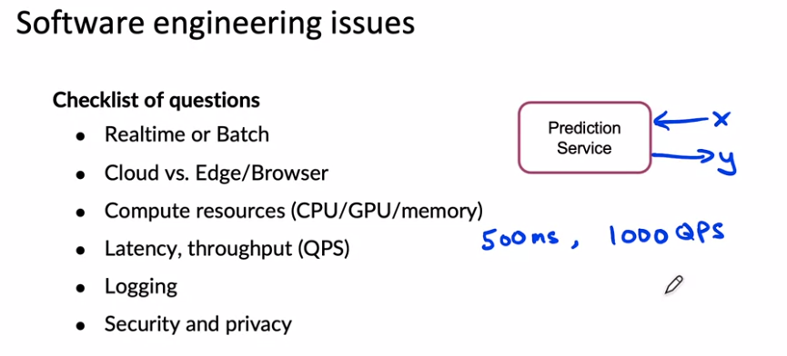

If you save this checklist somewhere, going through this when you're designing your software might help you to make the appropriate software engine choices when implementing your prediction service. To summarize, deploying a system requires two broad sets of tasks: there is writing the software to enable you to deploy the system in production. There is what you need to do to monitor the system performance and to continue to maintain it, especially in the face of concepts drift as well as data drift. One of the things you see when you're building machine learning systems is that the practices for the very first deployments will be quite different compared to when you are updating or maintaining a system that has already previously been deployed.

**Deployment patterns**

Not just turn on the model and hope for the best

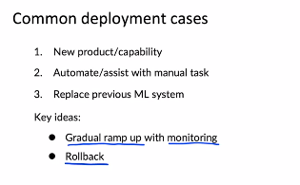

1. Example: new recognition system. Pattern: Start with low traffic and then catch up.
2. Already done by a person and we want to automate that task. Example: people in a factory checking subtraction.

Rollback: if the algorithm is not working is nice if we can go back to a previous working version.

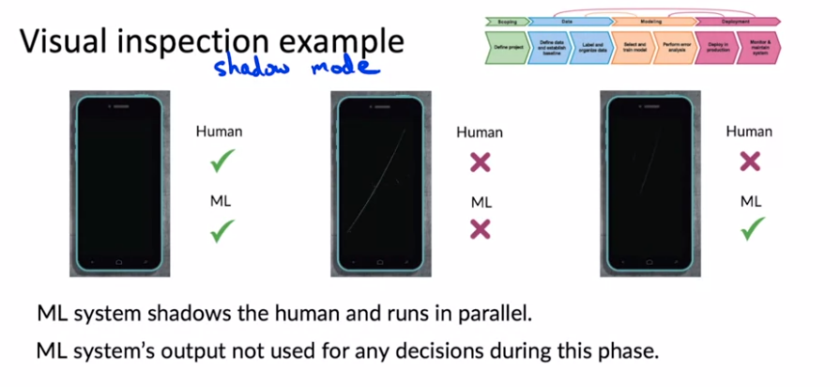

Canary: spot early on problems instead of when we have fully deployed.

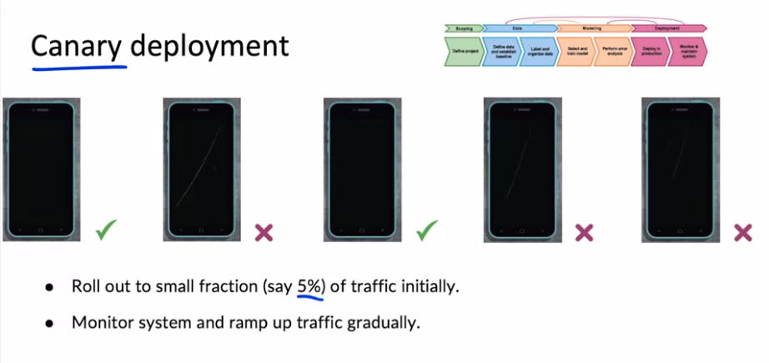

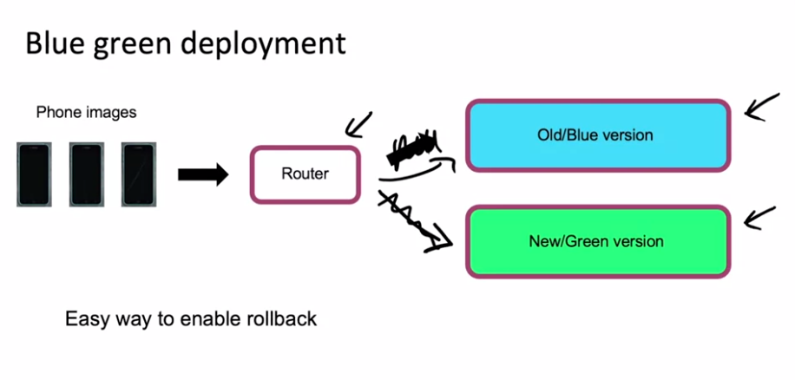

The router changes one deployment or the other

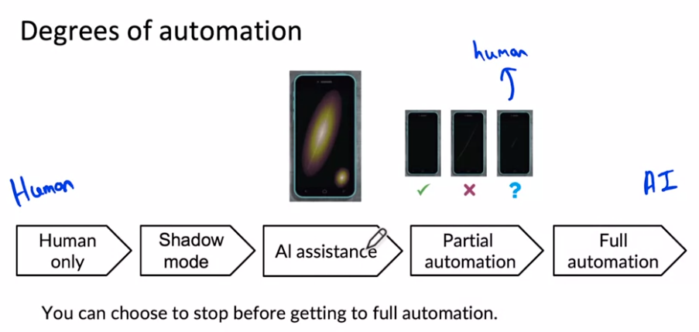

Human in the loop: Steps AI Assistance and Partial Automation

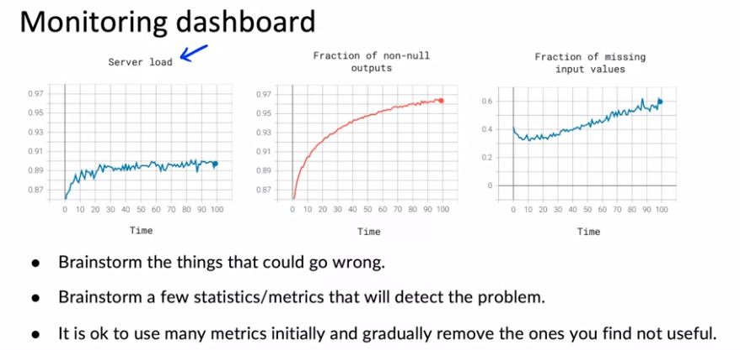

When I'm designing my monitoring dashboards for the first time, I think it's okay to start off with a lot of different metrics and monitor a relatively large set and then gradually remove the ones that you find over time not to be particularly useful.

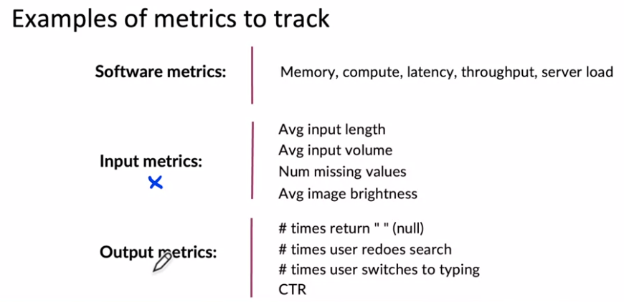

These output metrics can help you figure out if either your learning algorithm, output y has changed in some way, or if something that comes even after your learning algorithms output, such as the user's switching over to typing has changed in some significant way.

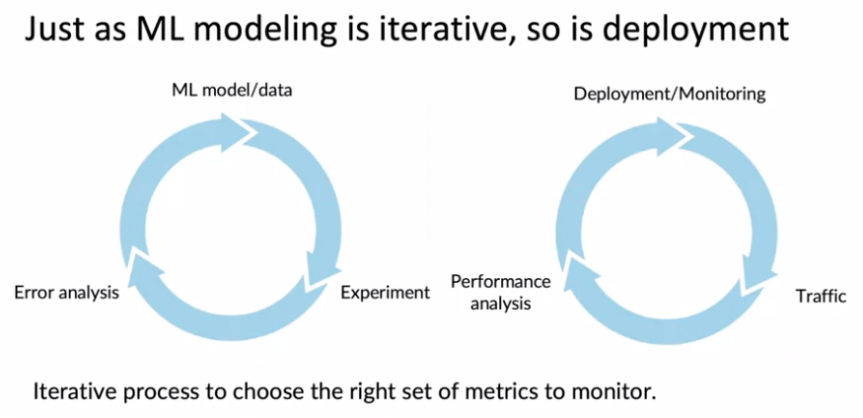

In my experience, it usually takes a few tries to converge to the right set of metrics to monitor.

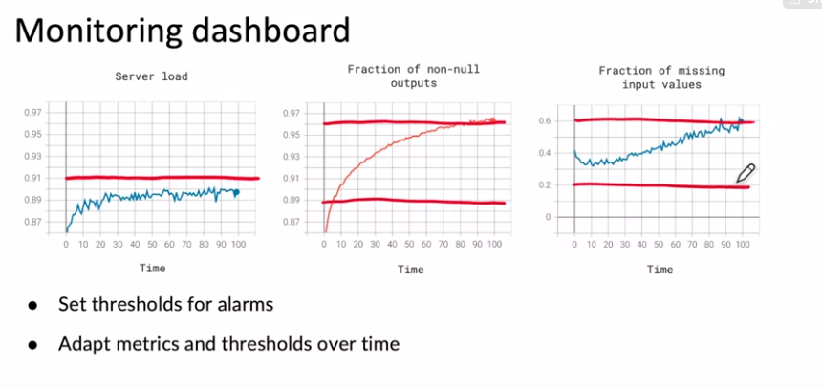

**Pipeline Monitoring**

Many AI systems are not just a single machine learning model running a prediction service, but instead involves a pipeline of multiple steps. So what are machine learning pipelines and how do you build monitoring systems for that?

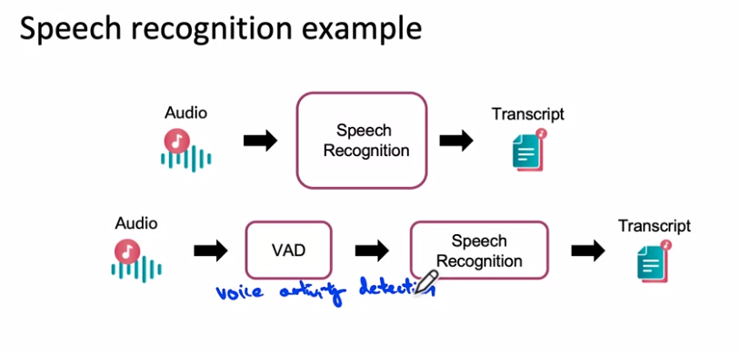

The voice activity detection module looks at the long stream of audio on your cell phone and clips or shortens the audio to just a part where someone is talking and streams only that to the cloud server to perform the speech recognition.

Both VAD and Speech Recognition are ML systems



Maybe it leaves more silence at the start or end or less silence at the start or end and thus if the VAD's output changes, that will cause the speech recognition systems input to change. And that could cause degraded performance of the speech recognition system

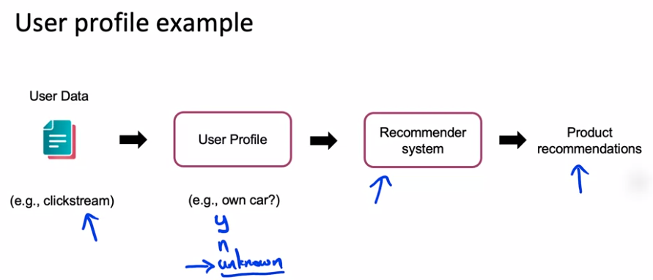

When you have a machine learning pipeline, these cascading effects in the pipeline can be complex to keep track of.

# 

### 

### Week 1 Optional References

### Week 1: Overview of the ML Lifecycle and Deployment

If you wish to dive more deeply into the topics covered this week, feel free to check out these optional references. You won’t have to read these to complete this week’s practice quizzes.

[Concept and Data Drift](https://towardsdatascience.com/machine-learning-in-production-why-you-should-care-about-data-and-concept-drift-d96d0bc907fb)

[Monitoring ML Models](https://christophergs.com/machine%20learning/2020/03/14/how-to-monitor-machine-learning-models/)

[A Chat with Andrew on MLOps: From Model-centric to Data-centric](https://youtu.be/06-AZXmwHjo)

Papers

Konstantinos, Katsiapis, Karmarkar, A., Altay, A., Zaks, A., Polyzotis, N., … Li, Z. (2020). Towards ML Engineering: A brief history of TensorFlow Extended (TFX).<http://arxiv.org/abs/2010.02013>

Paleyes, A., Urma, R.-G., & Lawrence, N. D. (2020). Challenges in deploying machine learning: A survey of case studies.<http://arxiv.org/abs/2011.09926>

Sculley, D., Holt, G., Golovin, D., Davydov, E., & Phillips, T. (n.d.). Hidden technical debt in machine learning systems. Retrieved April 28, 2021, from Nips.c<https://papers.nips.cc/paper/2015/file/86df7dcfd896fcaf2674f757a2463eba-Paper.pdf>

## 

## Week 2: Select and Train a Model

This week, our focus will be on the modeling part of the full cycle of a machine learning project, and you learn some suggestions for how to select and train the model, and how to perform error analysis, and use that to drive model improvements.

### **Selecting and Training a Model**

We will fix the model and focus on how we can improve the data in order to obtain better results

### 

### 

After you've done this enough times and achieve a good model, one last step that's often useful is to carry out a richer error analysis and have your system go through a final audit to make sure that it is working before you push it to a production deployment. So why is model development hard? When building a model, I think there are three key milestones that most projects should aspire to accomplish.

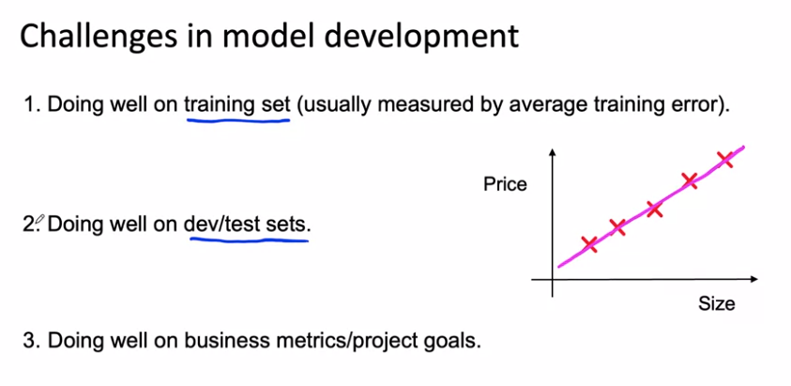

The job of a machine learning engineer would be much simpler if the only thing we ever had to do was do well on the holdout test set. As hard as it is to do well in the holdout test set, unfortunately, sometimes that isn't enough.

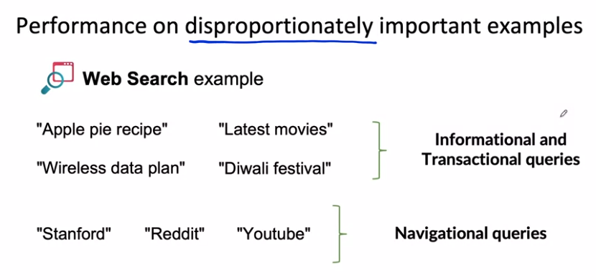

For informational and transactional queries, a web search engine wants to return the most relevant results, but users are willing to forgive maybe ranking the best result, Number two or Number three. There's a different type of web search query such as Stanford, or Reddit, or YouTube. These are called navigational queries, where the user has a very clear intent, very clear desire to go to Stanford.edu, or Reddit.com, or YouTube.com. When a user has a very clear navigational intent, they will tend to be very unforgiving if a web search engine does anything other than return Stanford.edu as the Number one ranked results and the search engine that doesn't give the right results will quickly lose the trust of its users.

Now one thing you could do is try to give these examples a higher weight. That could work for some applications, but in my experience, just changing the weights of different examples doesn't always solve the entire problem.

### Why low average error isn't good enough

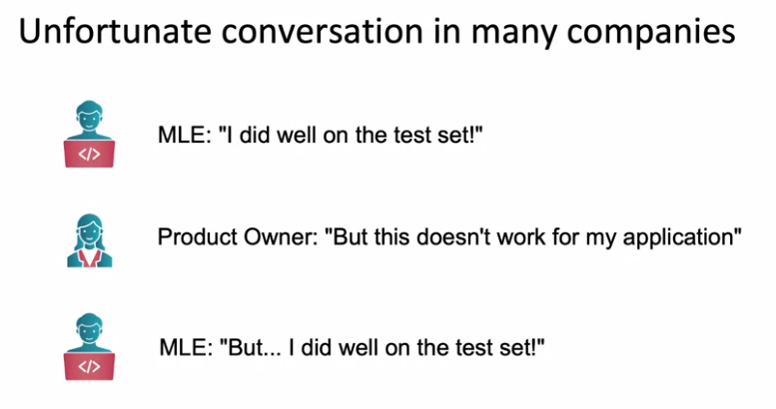

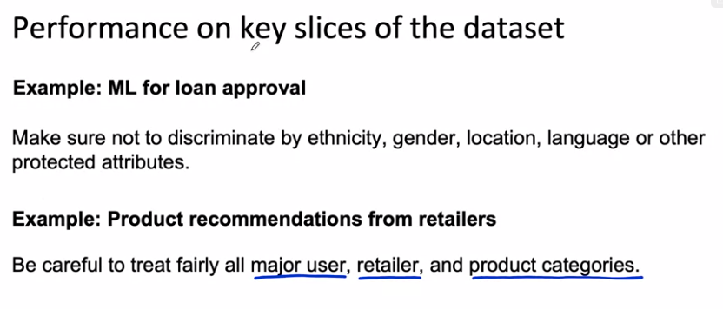

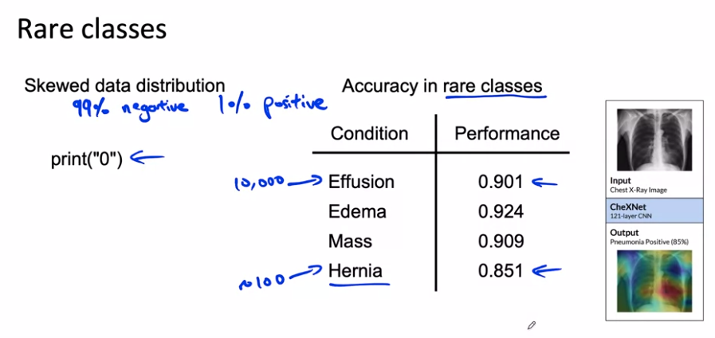

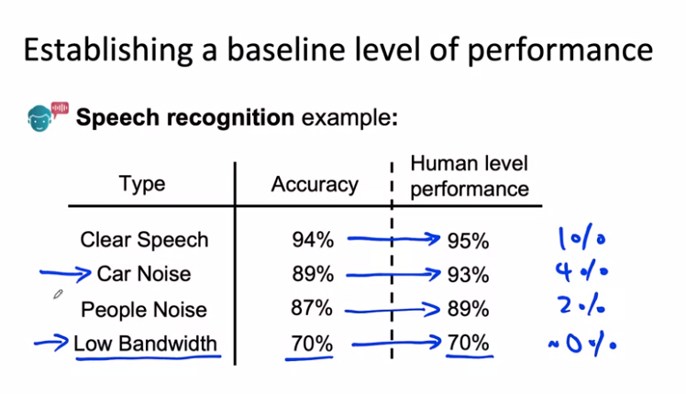

With this analysis, we realized that maybe the low bandwidth audio was so garbled. Even people, humans can't recognize what was said and it may not be that fruitful to work on that. Instead, it may be more fruitful to focus our attention on improving speech recognition with car noise in the background. In this example, using human level performance, which is sometimes abbreviated to HLP, Human Level Performance, gives you a point of comparison or a baseline that helps you decide where to focus your efforts on car noise data rather than on low bandwidth data.

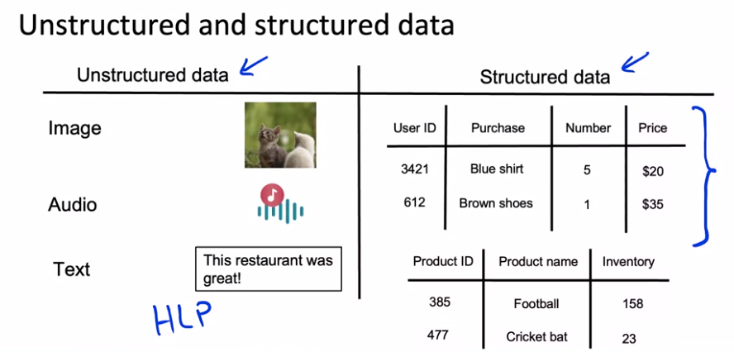

Human level performance (HLP) is generally more effective for establishing a baseline on unstructured data problems (such as images and audio) than structured data problems

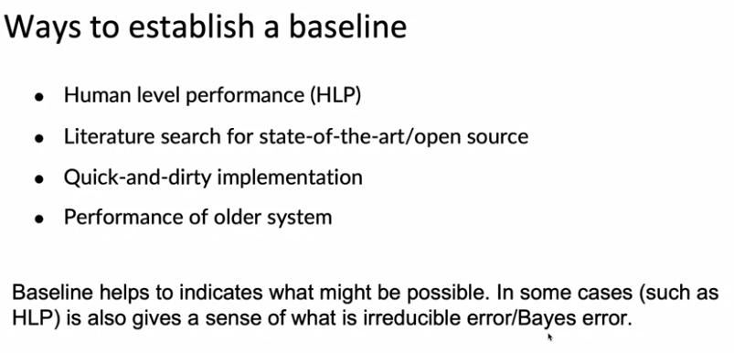

We've talked about how machine learning is an iterative process where you start with a model, data, hyperparameters, training model, carry out error analysis, and then use that to drive further improvements. After you've done this a few times, gone around the loop enough times, when you have a good enough model, you might then carry out a final performance audit before taking it to production. In order to get started on this first step of coming up with the model, here are some suggestions.

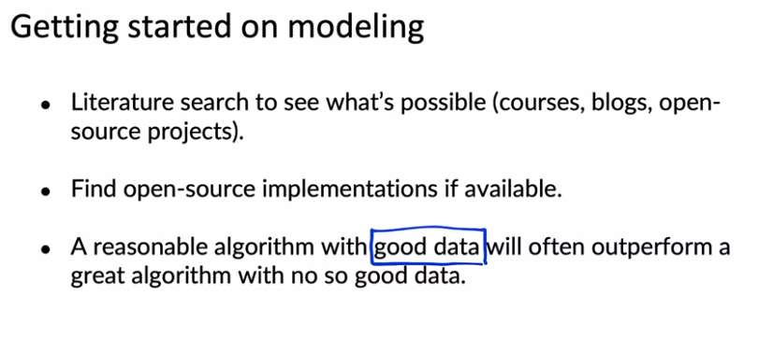

Don't obsess about taking the algorithm that was just published in some conference last week, that is the most cutting edge algorithm, instead find something reasonable, find a good open source implementation and use that to get going quickly. Because being able to get started on this first step of this loop, can make you more efficient in iterating through more times, and that will help you get to good performance more quickly.

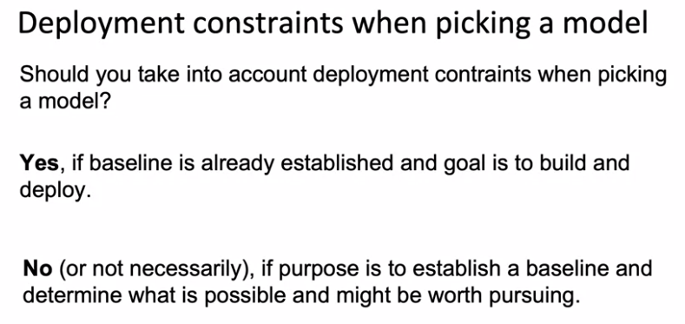

Finally, when trying out a learning algorithm for the first time, before running it on all your data, I would urge you to run a few quick sanity checks for your code and your algorithm. For example, I will usually try to overfit a very small training dataset before spending hours or sometimes even overnight or days training the algorithm on a large dataset. Maybe even try to make sure you can fit one training example, especially, if the output is a complex output. For example, I was once working on a speech recognition system where the goal was to input audio and have a learning algorithm output a transcript. When I trained my algorithm on just one example, one audio clip, when I trained my speech recognition system on just one audio clip on the training set, which is just one audio clip, my system outputs this, it outputs space, space, space, space, space, space. Clearly it wasn't working and because my speech system couldn't even accurately transcribe one training example, there wasn't much point to spending hours and hours training it on a giant training set.

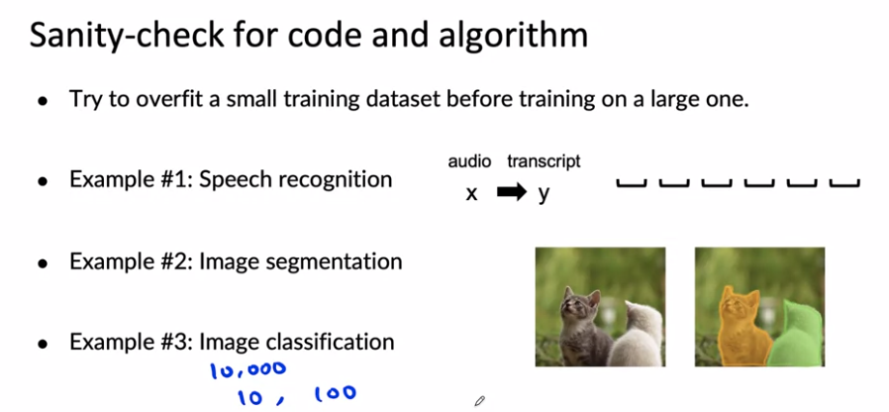

Now, after you've trained a machine learning model, after you've trained your first model, one of the most important things is, how do you carry out error analysis to help you decide how to improve the performance of your algorithm? Let's go on to the next video to dive into error analysis and performance auditing.

### Error analysis and performance auditing

### 

Until now, error analysis has typically been done via a manual process, say, in the Jupyter notebook or tracking errors in spreadsheets. I still sometimes do it that way and if that's how you're doing it too, that's fine. But there are also emerging MLOps tools that make this process easier for developers. For example, when my team landing AI works on computer vision applications, the whole team now uses Landing Lens, which makes this much easier than the spreadsheet.

**You've heard me say that training a model is an iterative process, deploying a model is an iterative process. Maybe it should come as no surprise that error analysis is also an iterative process.**

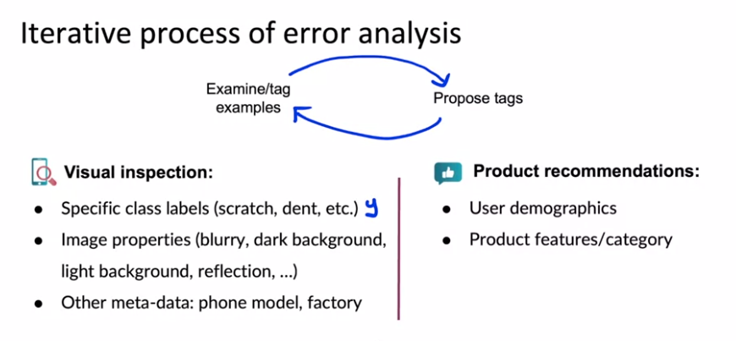

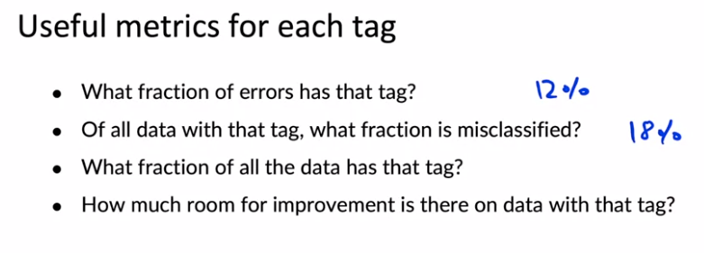

So by brainstorming different tags, you can segment your data into different categories and then use questions like these to try to decide what to prioritize working on.

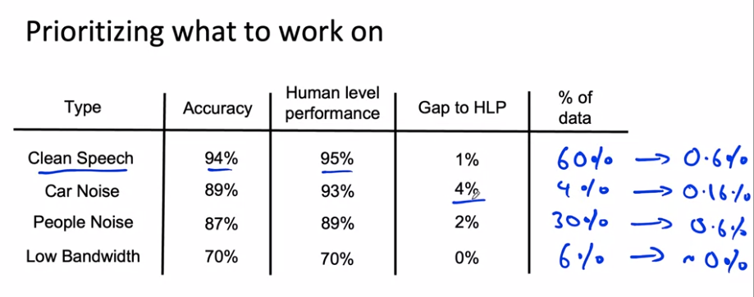

And so whereas previously we had said there's a lot of room for improvement in car noise, in this slightly richer analysis, we see that because people noise accounts for such a large fraction of the data, it may be more worthwhile to work on either people noise or maybe on clean speech because there's actually larger potential for improvements in both of those than for speech with car noise. So to summarize, when prioritizing what to work on, you might decide on the most important categories to work on based on, how much room for improvement there is, such as compared to human level performance or according to some baseline comparison.

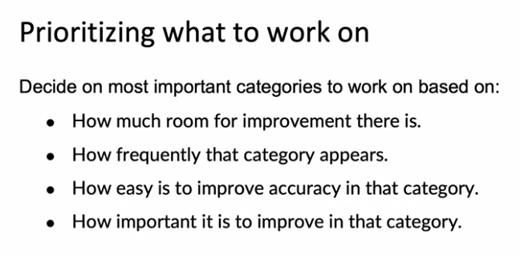

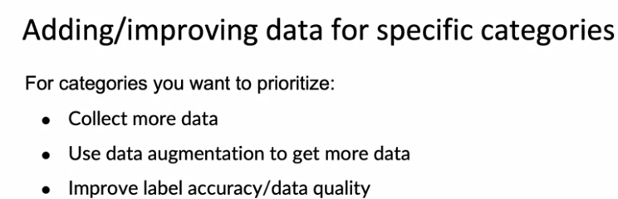

Data sets where the ratio of positive to negative examples is very far from 50-50 are called skewed data sets. Let's look at some special techniques for handling them.

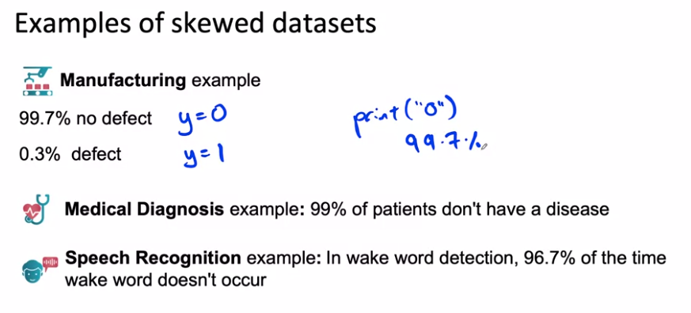

When you have a very skewed data set like this, raw accuracy is not that useful a metric to look at because Prince Zero can get very high accuracy. Instead, it's more useful to build something called the confusion matrix. A confusion matrix is a matrix where one axis is labeled with the actual label, is the ground truth label, y equals 0 or y equals 1 and whose other axis is labeled with the prediction.

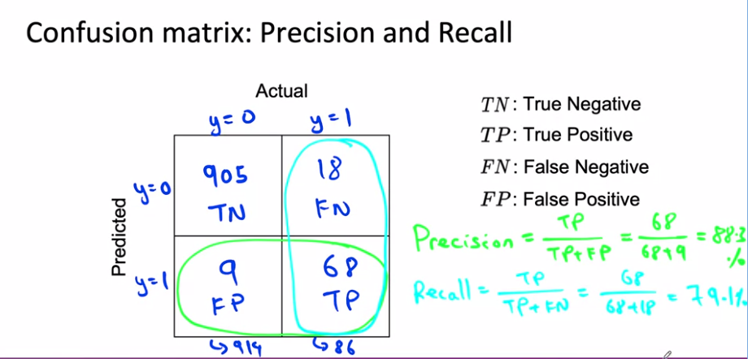

This is indeed a pretty skewed data set where out of 1000 examples there were 940 negative examples and just 86 positive examples, 8.6 percent positive, 91.4 percent negative.

Let's see what happens if your learning algorithm outputs zero all the time. It turns out it won't do very well on recall.

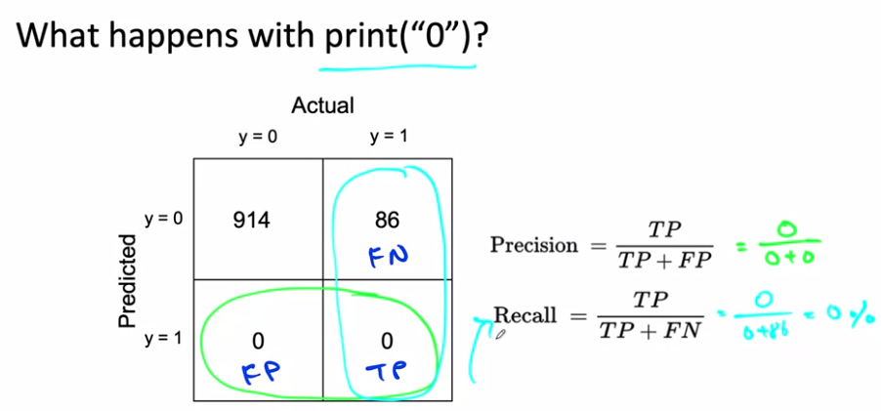

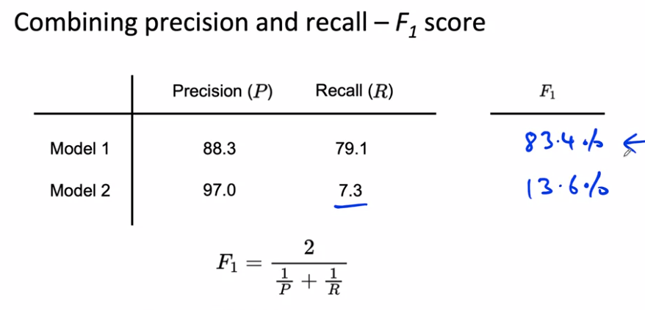

Being F1 the harmonic mean of Precision and recall, the score punished the model if one of those metrics gave a low score.

So far, we've talked about the binary classification problem with skewed data sets. It turns out to also frequently be useful for multi-class classification problems.

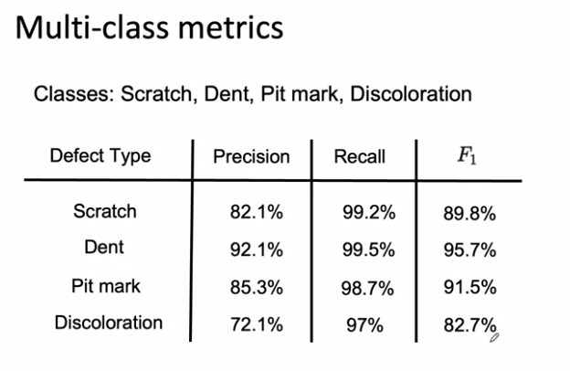

By combining precision and recall using F_1 as follows, this gives you a single number evaluation metric for how well your algorithm is doing on the four different types of defects and can also help you benchmark to human-level performance and also prioritize what to work on next. Instead of accuracy on scratches, dents, pit marks, and discolorations, using F_1 score can help you to prioritize the most fruitful type of defect to try to work on. The reason we use F_1 is because, maybe all four defects are very rare and so accuracy would be very high even if the algorithm was missing a lot of these defects. I hope that these tools will help you both evaluate your algorithm as well as prioritize what to work on, both in problems with skewed data sets and for problems with multiple rare classes.

### Performance auditing

Even when your learning algorithm is doing well on accuracy or F1-score or some appropriate metric is often worth one last performance audit before you push it to production. And this can sometimes save you from significant post deployment problems.

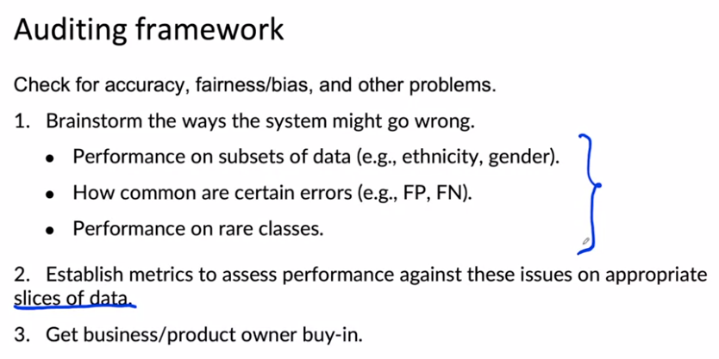

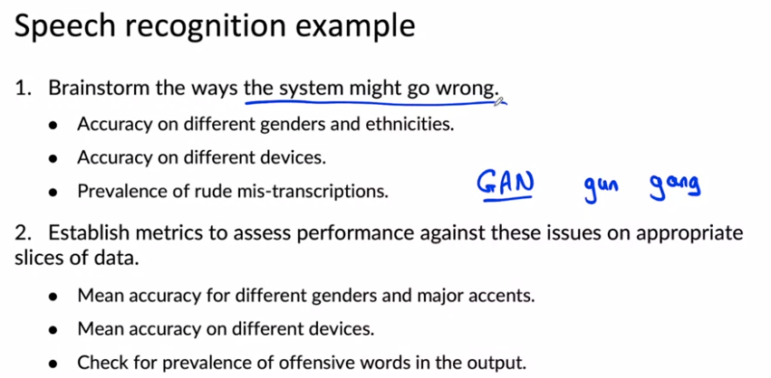

### Data iteration

With a model centric view of AI developments, you would take the data you have and then try to work really hard to develop a model that does as well as possible on the data because a lot of academic research on AI was driven by researchers, downloading a benchmark data set and trying to do well on that benchmark. Most academic research on AI is model centric, because the benchmark data set is a fixed quantity. In this view, model centric development, you would hold the data fixed and iterate the improvement. In this model centric view, you would hold the data fixed and iteratively improve the code or the model.

Which is to shift data from a model centric view to a data centric view. In this view, we think of the quality of the data as paramount, and you can use tools such as era analysis or data augmentation to systematically improve the data quality. For many applications, I find that if your data is good enough, there are multiple models that will do just fine. In this view, you can instead hold the code fixed and iteratively improve the data.

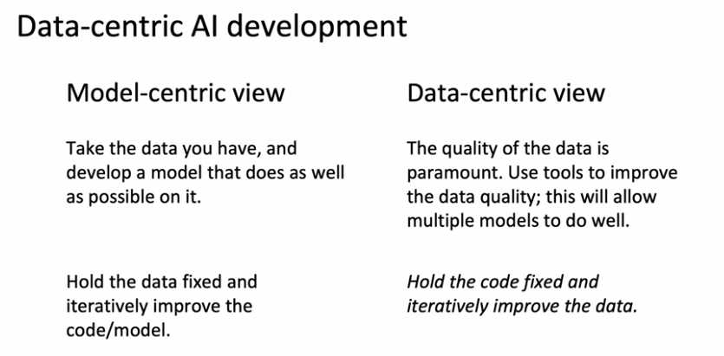

If you've been used to model centric thinking for most of your experience with machine learning, I would urge you to consider taking a data centric view as well, where when you're trying to improve your learning outcomes performance, try asking how you can make your data set even better?

### A useful picture of data augmentation

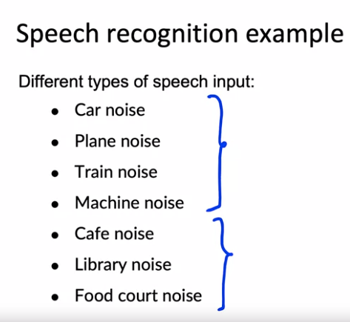

There are two types of noise: ones that come with mechanical noise and ones with human noise.

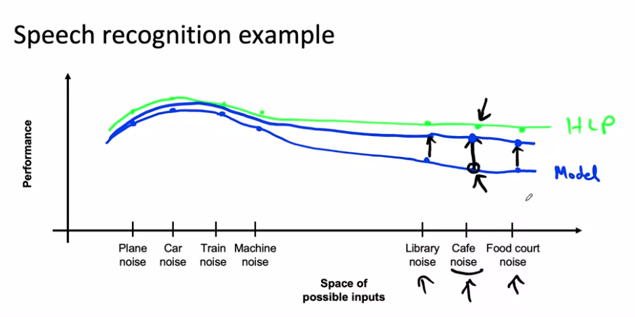

So this gap represents an opportunity for improvement. Now, what happens if you use data augmentation or maybe not data augmentation but go out to a bunch of actual cafes, to collect a lot more data with cafe noise in the background. What you'll do is, you'll take this point imagine grabbing a hold of these blue rubber bands or this rubber sheet, and pulling it upward like so. That's what you're doing if you collect or somehow get more data with cafe noise and add that to your training set, you're pulling up the performance of the algorithm on inputs with cafe noise. And what that will tend to do, is pull up this rubber sheet in the adjacent region as well. So if performance on cafe noise goes up, probably performance on the nearby points will go up to and performance on far away. Points may or may not go up as much. It turns out that for unstructured data problems, pulling up one piece of this rubber sheet is unlikely to cause a different piece of the rubber sheet to dip down really far below. Instead, pulling up one point causes nearby points to be pulled up quite a lot and far away points may be pulled up a little bit, or if you're lucky, maybe more than a little bit.

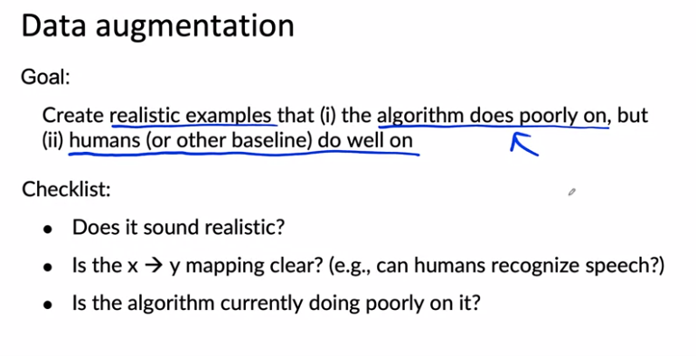

Let's say that you have a very small set of images of smartphones with scratches. Here's how you may be able to use data augmentation. You can take the image and flip it horizontally. This results in a pretty realistic image. The phone buttons are now on the other side, but this could be a useful example to add to your training set. Or you could implement contrast changes or actually brighten up the image here so the scratch is a little bit more visible. Or you could try darkening the image, but in this example, the image is now so dark that even I as a person can't really tell if there's a scratch there or not. Whereas these two examples on top would pass the checklist we had earlier, that the human can still detect the scratch well, this example is too dark, it would fail that checklist. I would try to choose the data augmentation scheme that generates more examples that look like the ones on top and fill the ones that look like the ones here at the bottom.

If you're using data augmentation, you're adding to specific parts of the training set such as adding lots of data with cafe noise. So now your training set may come from a very different distribution than the death set and the test set. Is this going to hurt your learning album's performance?

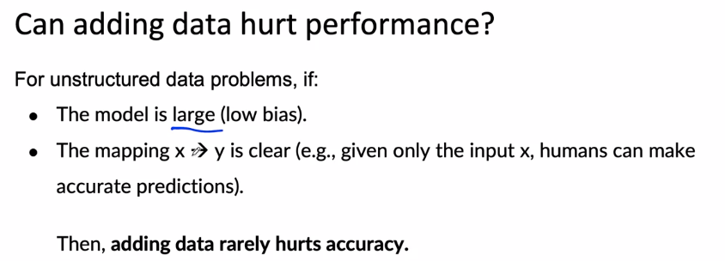

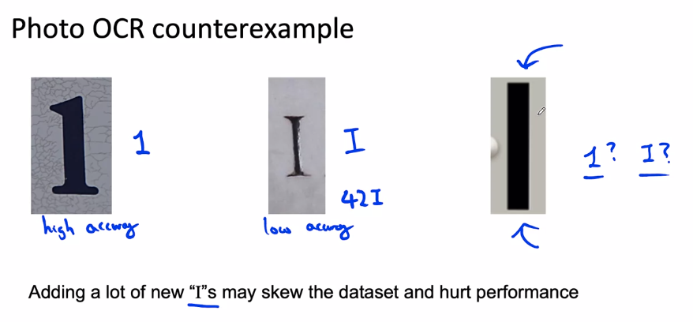

If we want to identify the “I”s we can use data augmentation, but by adding new examples the third option can be considered an “I” when, as being ambiguous, it should be considered a 1.

For many structured data problems. It turns out that creating brand new training examples is difficult, but there's something else you could do which is to take existing training examples and figure out if there are additional useful features you can add to it.

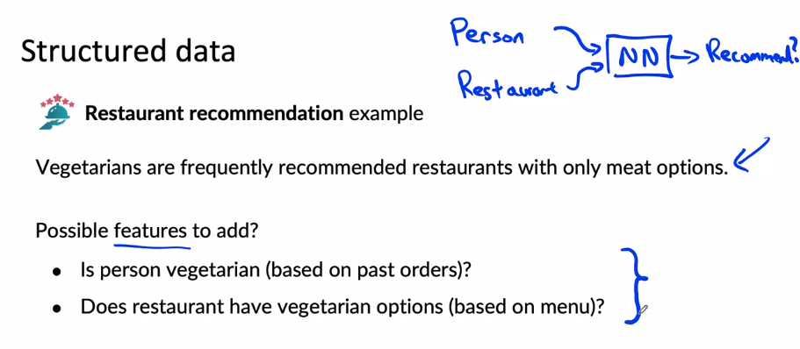

Additional features like these, can be hand coded or they could in turn be generated by some learning algorithm, such as having a learning average home, try to read the menu and classify meals as vegetarian or not, or having people call this manually could also work depending on your application.

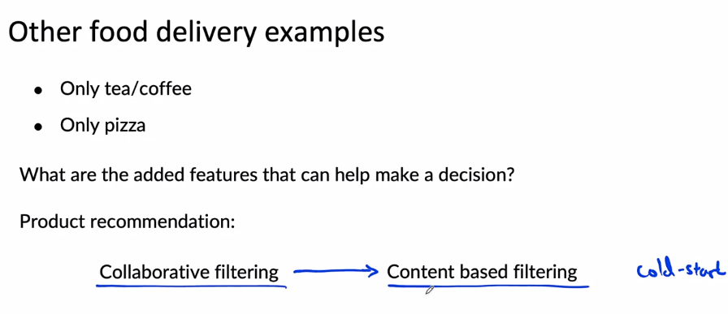

Over the last several years, there's been a trend in product recommendations of a shift from collaborative filtering approaches to what content based filtering approaches. Collaborative filtering approaches is loosely an approach that looks at the user, tries to figure out who is similar to that user and then recommends things to you that people like you also liked. In contrast, a content based filtering approach will tend to look at you as a person and look at the description of the restaurant or look at the menu of the restaurants and look at other information about the restaurant, to see if that restaurant is a good match for you or not. The advantage of content based filtering is that even if there's a new restaurant or a new product that hardly anyone else has liked by actually looking at the description of the restaurant, rather than just looking at who else likes the restaurants, you can more quickly make good recommendations. This is sometimes also called the Cold Start Problem. How do you recommend a brand new product that almost no one else has purchased or likes or dislikes so far? And one of the ways to do that is to make sure that you capture good features for the things that you might want to recommend. Unlike collaborative filtering, which requires a bunch of people to look at the product and decide if they like it or not, before it can decide whether a new user should recommend the same product. 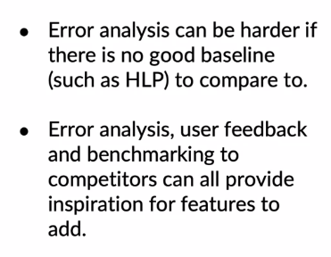

As you're working to iteratively improve your algorithm. One thing that'll help you be a bit more efficient is to make sure that you have robust experiment tracking.

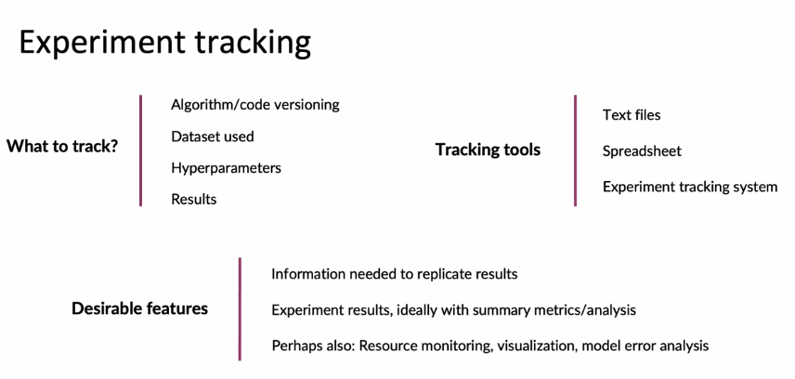

Rather than worrying too much about exactly which experiment tracking framework to use though, the number one thing I hope you take away from this video is, do got to have some system, even if it's just a text file or just a spreadsheet for keeping track of your experiments and include as much information as is convenient to include. Because later on, if you try to look back, remember how you had generated a certain model, having that information would be really useful for helping you to replicate your own results.

I'd like to leave you with a thought on shifting from big data to good data.

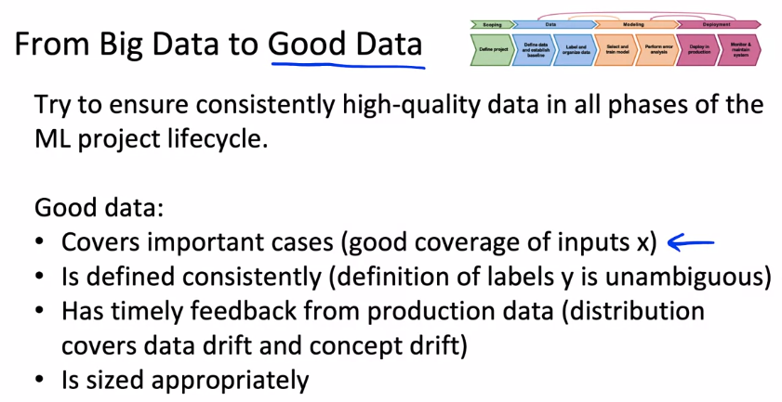

### 

### Week 2 Optional References

### Week 2: Select and Train Model

If you wish to dive more deeply into the topics covered this week, feel free to check out these optional references. You won’t have to read these to complete this week’s practice quizzes.

[Establishing a baseline](https://blog.ml.cmu.edu/2020/08/31/3-baselines/)

[Error analysis](https://techcommunity.microsoft.com/t5/azure-ai/responsible-machine-learning-with-error-analysis/ba-p/2141774)

[Experiment tracking](https://neptune.ai/blog/ml-experiment-tracking)

Papers

Brundage, M., Avin, S., Wang, J., Belfield, H., Krueger, G., Hadfield, G., … Anderljung, M. (n.d.). Toward trustworthy AI development: Mechanisms for supporting verifiable claims∗. Retrieved May 7, 2021<http://arxiv.org/abs/2004.07213v2>

Nakkiran, P., Kaplun, G., Bansal, Y., Yang, T., Barak, B., & Sutskever, I. (2019). Deep double descent: Where bigger models and more data hurt. Retrieved from<http://arxiv.org/abs/1912.02292>

## 

## Week 3: Data Definition and Baseline

This week we dive into data. How do you get data that sets up your training, your modeling for success?

### Define Data and Establish Baseline

#### Why is data definition hard?

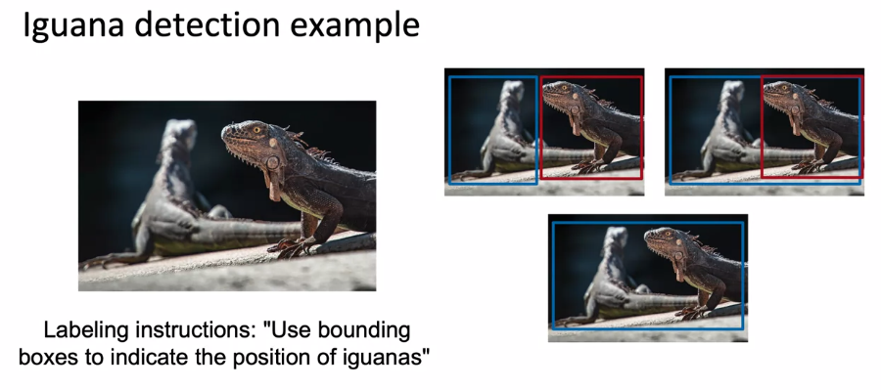

Three diligent, hard working laborers can come up with these three very different ways of labeling iguana's, and maybe any of these is actually fine. I would prefer the top two rather than the 3rd one. But any of these labeling conventions could result in you learning algorithm, learning a pretty good iguana detector.

But what is not fine is if 1/3 of your laborers use the 1st and 1/3 the 2nd, and 1/3, the 3rd labeling convention, because then your labels are inconsistent, and this is confusing to the learning algorithm.



I think the 2nd laborer probably did a better job. But then a 3rd laborer may look at this and say, well, here's a bounding box that shows you where the defects are. Between these three labels, probably the one in the middle would work the best.

What we would do this week is dive into best practices for the data stage of the full cycle of a machine learning project. Specifically, we'll talk about how to define what is the data, what should be x and what should be y and establish a baseline and doing that well will set you up to label and organize the data well, which would give you a good data set for when you move into the modeling phase.

#### More label ambiguity examples

One way to transcribe this would be "Um, nearest gas station." In some places, people spell "um" with two m's. That would be a different way to spell it. We could have used dot-dot-dot or ellipses instead of the comma as well, which would be another ambiguity. Or given the audio had noise after the last words. Nearest gas station. Did they say something after the nearest gas station? I'm not sure actually. Would you transcribe it like this instead? There are combinatorially many ways to transcribe this. With one M or two M's, comma or ellipses, whether to write unintelligible at the end of this. Being able to standardize on one convention will help your speech recognition algorithm.

Let's also look at an example of structured data.

A common application in many large companies is user ID merge. That's when you have multiple data records that you think correspond to the same person and you want to merge these user data records together.

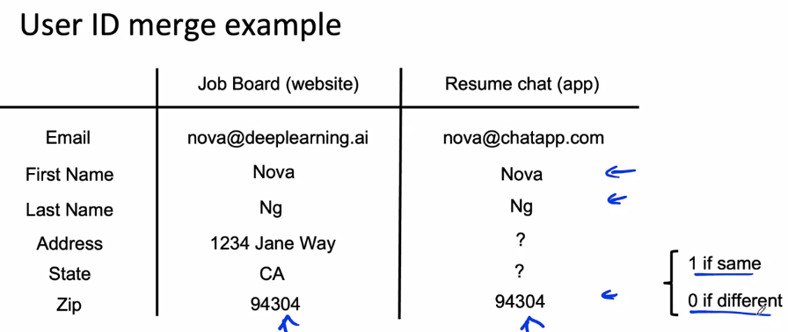

Now, say your company acquires a second company that runs a mobile app that allows people to login, to chat and get advice from each other about their resumes. It seems synergistic for your business. If you run a listing of online jobs, maybe you merge or acquire a second company that runs a mobile app that lets people chat about their resumes and from this mobile app, you have a different database of users. Given this data record and this one, do you think these two are the same person? One approach to the User ID merge problem, is the use of supervised learning algorithm that takes as inputs to user data records and tries to output either one or zero based on whether it thinks these two are actually the same physical human being. If you have a way to get ground truth data records, such as if a handful of users are willing to explicitly link the two accounts, then that could be a good set of labeled examples to train an algorithm. But if you don't have such a ground true set of data, what many companies have done is ask human labors, sometimes a product management team to just manually look at some pairs of records that have been filtered to have maybe similar names or similar ZIP codes, and then to just use human judgment to determine if these two records appear to be the same person. Because whether these two records really are the same person, is genuinely ambiguous.

A few other examples from structured data. If you are trying to use the learning algorithm to look at the user account like this and predict is it a bot or a spam account?

Sometimes that can be ambiguous. Or if you look at an online purchase, is this a 40-length transaction? Has someone stolen accounts and is using stolen accounts to interact with your websites or to make purchases? Sometimes that too is ambiguous. Or if you look at someone's interactions with your website and you want to know, are they looking for a new job at this moment in time based on how someone behaves on a job board website or a resume chat app, you can sometimes guess if they're looking for a job, but it's hard to be sure. That's also a little bit ambiguous. In the face of potentially very important and valuable prediction tasks like these, the ground truth can be ambiguous. If you ask people to take their best guess at the ground truth label for tasks like these, giving labeling instructions that results in more consistent and less noisy and less random labels will improve the performance of your learning algorithm.

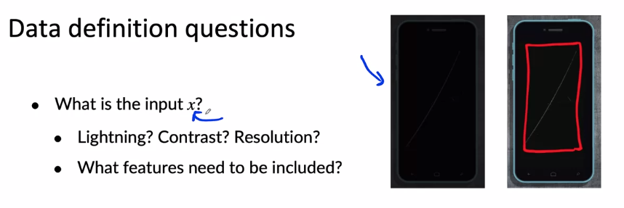

When defining the data for your learning algorithm, here are some important questions. First, what is the input x? For example, if you are trying to detect defects on smartphones, for the pictures you're taking, is the lighting good enough? Is the camera contrast good enough? Is the camera resolution good enough? If you find that you have a bunch of pictures like these, which are so dark, it's hard even for a person to see what's going on. The right thing to do may not be to take this input x and just label it. It may be to go to the factory and politely request improving the lighting because it is only with this better image quality that the labor can then more easily see scratches like this and label them.

In addition to defining the input x, you also have to figure out what should be the target label y. As you've seen from the preceding examples, one key question is, how can we ensure labels give consistent labels?

#### Major types of data problems

It turns out that the best practices for organizing data for one type can be quite different than the best practices for totally different types.

Do you have a relatively small data set? Do you have relatively small datasets or do you have a very large data set? There is no precise definition of what exactly is small and what is large? But I'm going to use it as a slightly arbitrary threshold, whether you have over 10,000 examples or not. And clearly this boundary is a little bit fuzzy and the transitions from small to big data sets is a gradual one. 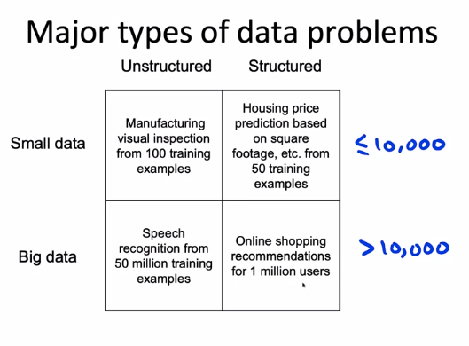

And the reason I chose the number 10,000 is that's roughly the size beyond which it becomes quite painful to examine every single example yourself.

For a lot of **unstructured data problems**, people, Can help you to label data and data augmentation such as synthesizing new images or synthesizing new audio. And there's some emerging techniques for synthesizing new text as well, but data augmentation can help. So for manufacturing vision inspection, you can use data augmentation to maybe generate more pictures of smart films or for speech recognition. Data augmentation can help you synthesize audio clips with different background noise. In contrast for **structured data problems**, it can be harder to obtain more data and also harder to use data augmentation, if only 50 houses have been so recently in that geography. Well, it's hard to synthesize new houses that don't exist or if you have a million users in your database, again, it's hard to synthesize new users that don't really exist. And it's also harder not impossible, still worth trying, but it may or may not be possible to get humans to label the data. So I find that the best practices for unstructured versus structured data are quite different.

The second axis is the size of your data set. When you have a relatively small data set, having clean labels is critical. If you have 100 training examples, then if just one of the examples is mislabeled, that's 1% of your data set. And because the data set is small enough for you or a small team to go through it efficiently, it may well be aware of your while to go through that 100 examples. And make sure that every one of those examples is labelled in a clean and consistent way, meaning according to a consistent labeling standard. In contrast, if you have a million data points, it can be harder. Maybe impossible for a small machine learning team to manually go through every example. Having clean labels is still very helpful, don't get me wrong. Even when you have a lot of data, clean labels are better than non clean ones.

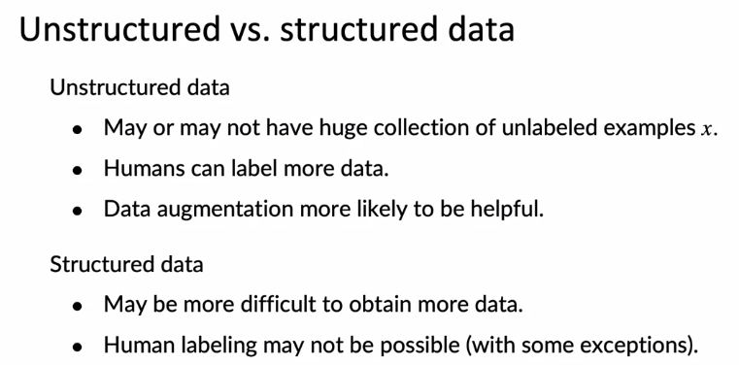

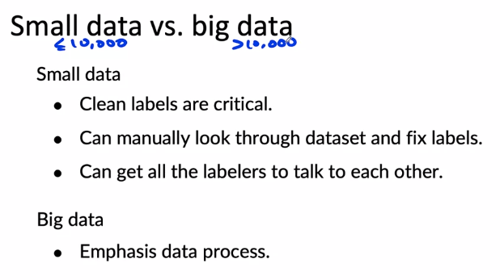

#### Small data and label consistency

In problems of a small dataset. Having clean and consistent labels is especially important. Let's start with an example. One of the things I used to do is use machine learning to fly helicopters. One thing you might want to do is take the input voltage applied to the motor or to the helicopter rotor and predict what's the speed of the rotor. You can have this type of problem, not just to find helicopters before other control problems with controlling the speed of the motor.

So a pretty small data set because this data set that is the output Y is pretty noisy, it is difficult to know what is the function. It's difficult to know what is the function you should use to map voltage to the rotor speed in rpm. Maybe it should be a straight line.

Now, if you had a ton of data, this data set is equally noisy as the one on the left, but you just have a lot more data. Then the learning algorithm can average over the noisy data sets and you can now fill a function.

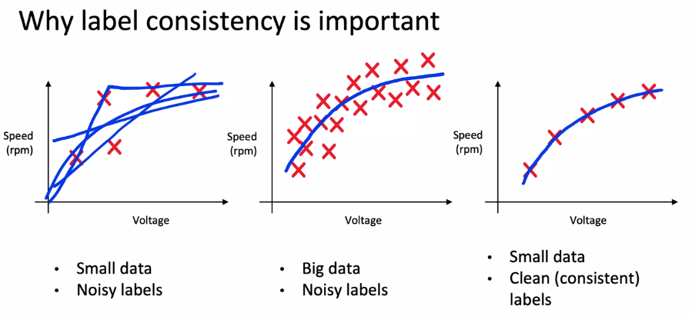

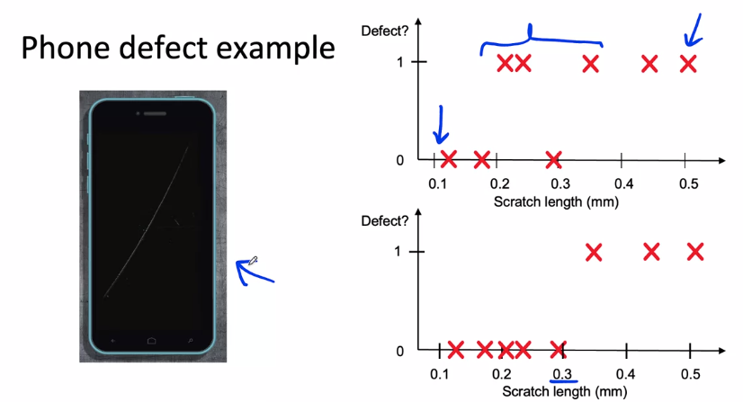

So one solution to this would be to say, why don't we try to get a lot more pictures of phones and scratches. And then see what the inspectors do and then maybe eventually we can train a neural network. They can figure out from the image what is and what isn't a scratch on average. Maybe that approach could work, but it'd be a lot of work and require collecting a lot of images. I found that it can be more fruitful to ask the inspectors to sit down and just try to reach agreement on what is the size of scratch. That would cause them to label a scratcher of a bounding box versus decide is too small and not worth bothering labeling.

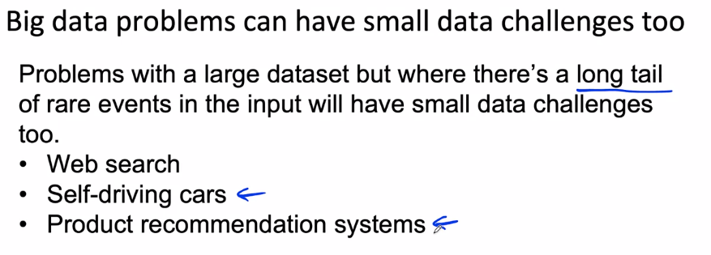

#### Improving label consistency

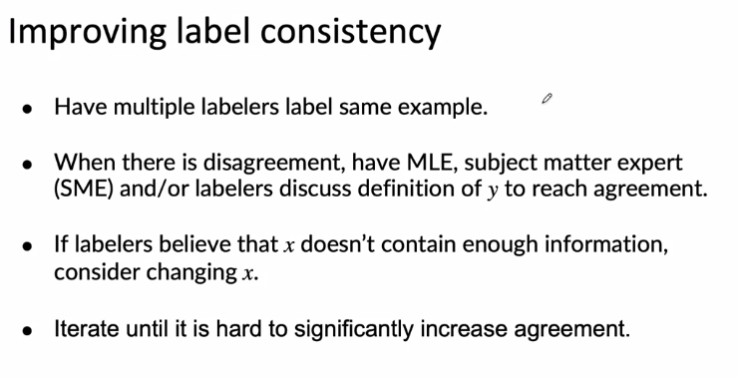

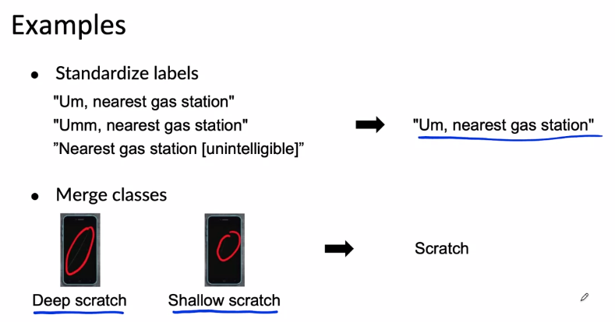

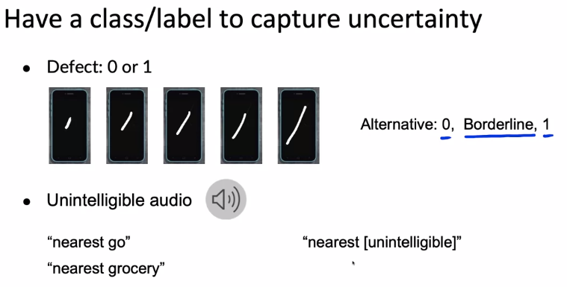

Maybe everyone agrees that the giant scratch is a defect, a tiny scratch is not a defect, but they don't agree on what's in between. If it was possible to get them to agree, then that would be one way to reduce label ambiguity. But if that turns out to be difficult, then here's another option; which is to create a new class where you now have three labels. You can say, it's clearly not a defect, or clearly a defect, or just acknowledge there's some examples that are ambiguous and put them in a new borderline class. If it becomes easier to come up with consistent instructions for this three class problem, because maybe some examples are genuinely borderline, then that could potentially improve labeling consistency.

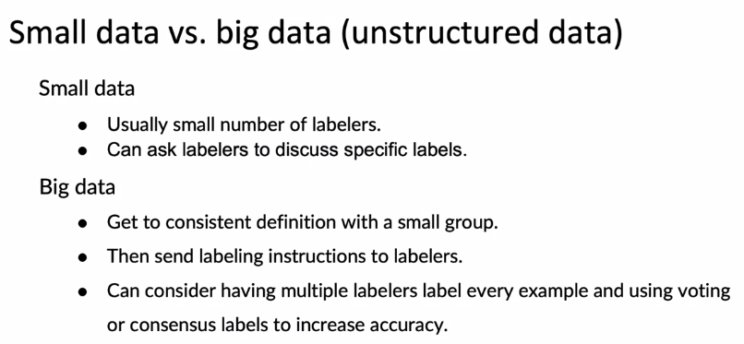

#### Human level performance (HLP)

Human Level Performance is also sometimes misuse.

One of the most important users of measuring Human Level Performance or HLP is to estimate based error or irreducible error. Especially on unstructured data tasks in order to help with their analysis and prioritization and just establish what might be possible.

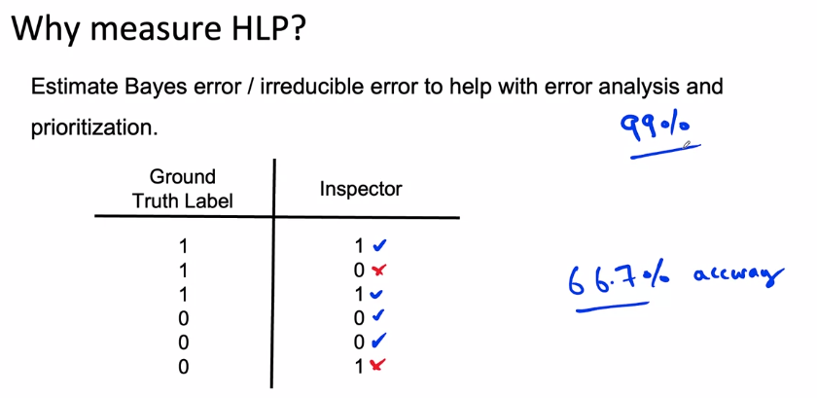

And so this would let you go back to the business owner and say look, even your inspector is only 66.7% accuracy. How can you expect me to Get 99% accuracy?

There's one question that is often not asked, which is what exactly is this Ground Truth Label? Because rather than just measuring how well we can do compared to some Ground Truth Label, which was probably written by some other human. Are we really measuring what is possible or are we just measuring how well two different people happen to agree with each other? When the Ground Truth Label is itself determined by a person. There's a very different approach to thinking about Human Level Performance.

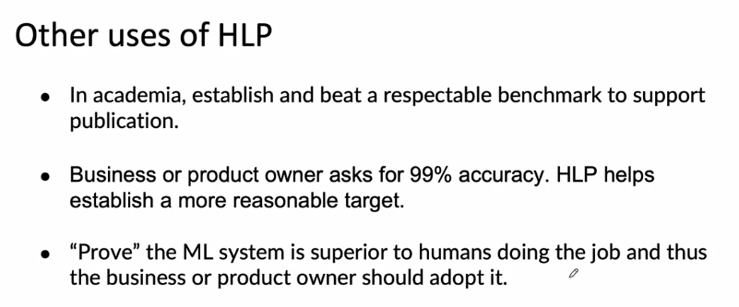

As tempting as it is to go to someone and say look, I've proved that my machinery system is more accurate than humans inspecting the phones or the radiologist reading X-rays or something. And now that I've mathematically proved the superiority of my learning album, you have to use it right? I know the logic of that is tempting, but as a practical matter, this approach rarely works. And you also saw last week that businesses need systems that do more than just doing well on average test set accuracy. So if you ever find yourself in this situation, I would urge you to just use this type of logic with caution or maybe even more preferably just don't use these arguments.

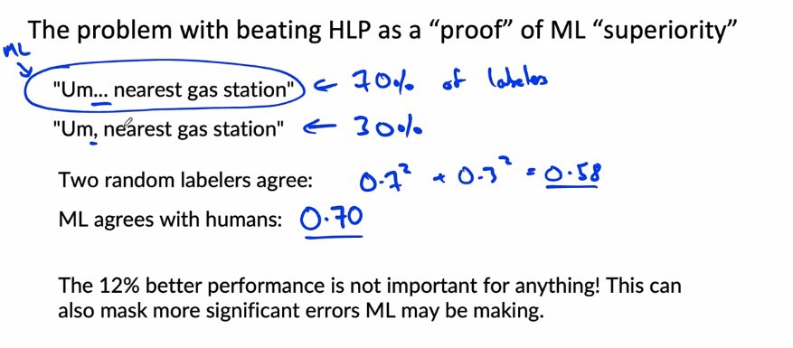

#### Raising HLP

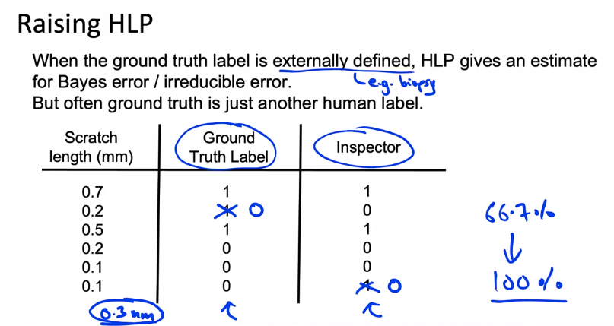

Rather than just aspiring to beat the human inspector, it may be more useful to see why the ground truth, which is just some other inspector compared to this inspector don't agree.

have them agree that 0.3 mm is the threshold above which a stretch becomes a defect, then what we realize is that for the first example, both label that one totally appropriately. For the second example, the ground truth here is one but is less than 0.3, so we really should change this to zero,

If we go through this exercise of getting the ground truth label and this inspector to agree, then we actually just raise human-level performance from 66.7 percent to 100 percent, at least as measured on these six examples. But notice what we've done, by raising HLP to 100 percent we've made it pretty much impossible for learning algorithm to beat HLP, so that seems terrible. You can't tell the business owner anymore, you beat HLP, and thus they must use your system. But the benefit of this is you now have much cleaner, more consistent data, and that ultimately will allow your learning algorithm to do better. When you go is to come up with a learning algorithm that actually generates accurate predictions rather than just proof for some reason that you can beat HLP. I find this approach of working to raise HLP to be more useful.

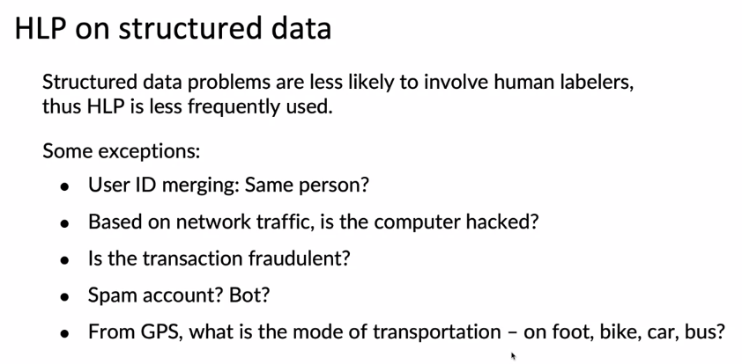

### Label and Organize Data

#### Obtaining data

#### 

How much time should you spend obtaining data? You know that machine learning is a highly iterative process where you need to pick a model, hyperparameters, have a data set, then training to carry out our analysis and go around this loop multiple times to get to a good model.

"Hey everyone, we're going to spend at most seven days collecting data, so what can we do?" I found that posing the question that way often leads to much more creative ways.

One exception to this guideline is if you have worked on this problem before, and if from experience you know you need at least a certain training set size. Then it might be okay to invest more effort up front to collect that much data.

In terms of getting the data you need, one other step I often carry out is to take inventory of possible data sources.

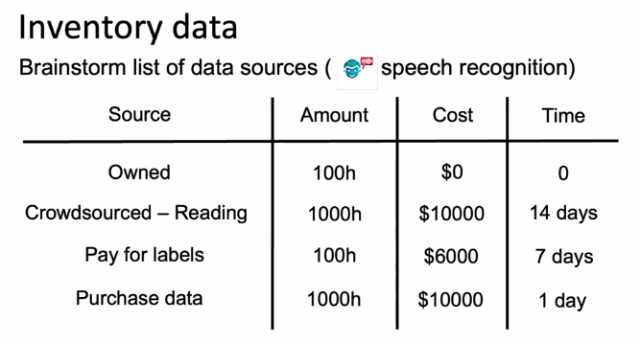

The three most common ways to get data labeled are, in house where you have your own team label the data, versus outsource where you might find some company that labels data and have them do it for you, versus crowdsource where you might use a crowdsourcing platform to have a large group collectively label the data. The difference between outsource versus crowdsource is that, depending on what type of data you have, there may be specialized companies that could help you get the label quite efficiently.

Some of the trade offs between these options, having machine learning engineers label data is often expensive. But I find that to get a project going quickly, having machine learning engineers do this just for a few days is usually fine and in fact, this can help build the machine learning engineers intuition about the data.

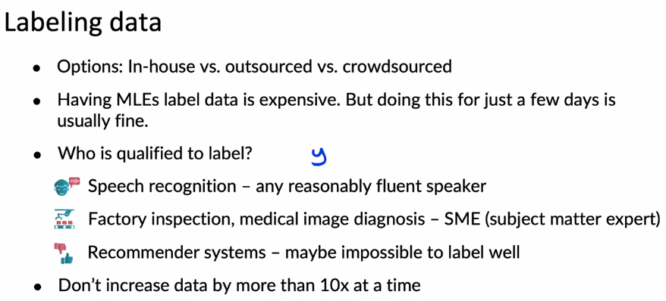

I found this really hard to predict what will happen when your data set size increases even beyond that. Is also fine to increase your dataset size 10 percent or 50 percent or just 2x at a time, so this is only an upper bound for how much you might invest to increase your dataset size. This guideline hopefully will help teams avoid over investing in tons of data, only to realize that collecting quite that much data wasn't the most useful thing they could have done.

#### Data pipeline

Data pipelines, sometimes also called Data Cascades refers to when your data has multiple steps of processing before getting to the final output.

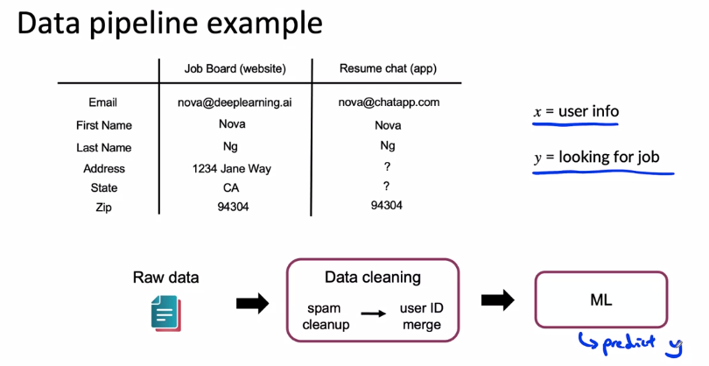

How do you replicate the strips to make sure that the input distribution to a machine learning algorithm was the same for the development data and the production data? I find that the amount of effort that you should invest to make sure that the pre-processing scripts are highly replicable can depend a little bit on the face of the project. I know that it may be fashionable to say that everything you do should be 100 percent replicable

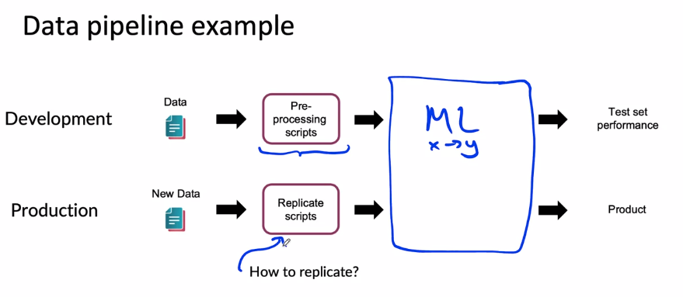

A lot of projects do go through a proof of concept or POC phase, and then a production phase where during the **proof of concept** phase, the primary goal is just to decide if the application is workable and worth building and deploying.

Once you decide that this project is worth taking to production, then you know it's going to be really important to replicate any preprocessing scripts. In this phase, that's when I would use more sophisticated tools to make sure the entire data pipeline is replicable. This is when tools which can be a little bit more heavyweight, but tools like TensorFlow Transform, Apache beam, Airflow, and so on become very valuable.

#### Meta-data, data provenance and lineage

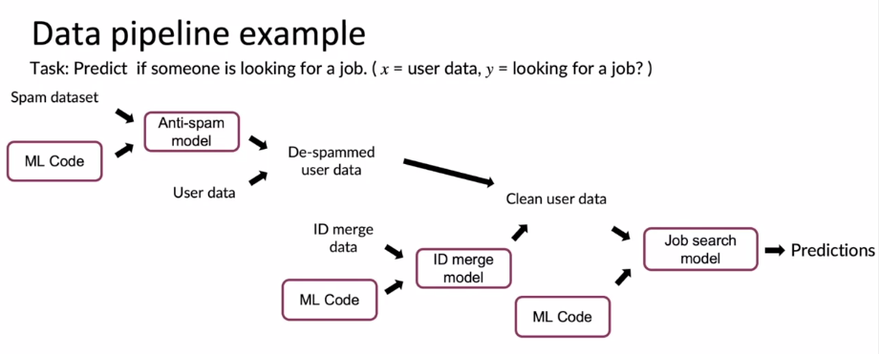

What if after running this system for months, you discover that, oops, the IP address blacklists you're using have some mistakes in it. In particular, what if you discover that there were some IP addresses that were incorrectly blacklisted.

How do you go back and fix this problem? Especially if each of these systems was developed by different engineers, and you have files spread across the laptops of your machine learning engineering development team. To make sure your system is maintainable, especially when a piece of data upstream ends up needing to be changed, it can be very helpful to keep track of data provenance as well as lineage. **Data provenance** refers to where the data came from. Who did you purchase the spam IP address from? **Lineage** refers to the sequence of steps needed to get to the end of the pipeline.

To be honest, the tools for keeping track of data provenance and lineage are still immature into this machine learning world. I find that extensive documentation can help and some formal tools like TensorFlow Transform can also help but solving this type of problem is still not something that we are great at as a community yet.

**Metadata** is data about data. For example, in manufacturing visual inspection, the data would be the pictures of phones and the labels but if you have metadata that tells you what time was this picture of a phone taken, what factory was this picture from, what's the line number, what were the camera settings such as camera exposure time and camera aperture, what's the number of the phone you're inspecting, what's the ID of the inspector that provided this label. These are examples of data about your dataset X and Y. This type of metadata can turn out to be really useful because if you discover, during machine learning development, that for some strange reason, line number 17 in factory 2 generates images that produce a lot more errors for some reason. Then this allows you to go back to see what was funny about line 17 and factory 2. But if you had not stored the factory in line number metadata in the first place, then it would have been really difficult to discover this during error analysis.

My tip is if you have a framework or a set of MLOps tools for storing metadata, that will definitely make life easier but even if you don't, just like you rarely regret commenting your code, I think you will really regret storing metadata that could then turn out to be useful later.

One more example for speech recognition. If you have audio recorded from different brands of smartphones, let's say that in advance, or if you have different labelers labeling your speech, or if you use a voice activity detection model, then just keep track of what was their version number of the voice activity detection model that you use. All of these means that in case for some reason, one version of the VAD, voice activity detection system results in much larger errors, this significantly increases the odds of you discovering that and really use that to improve your learning algorithm performance.

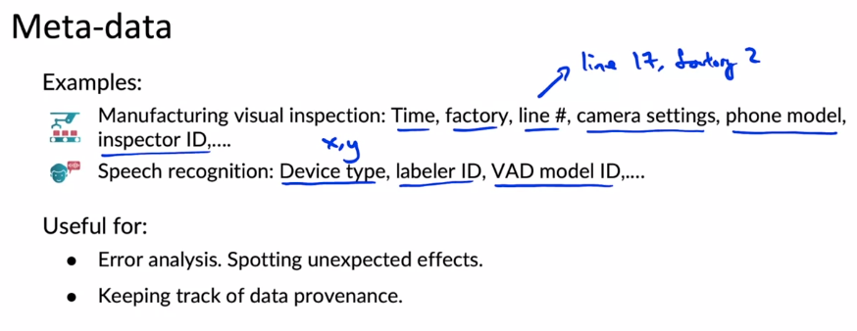

#### Balanced train/dev/test splits

This makes your dev set quite non representative because in your dev set you have only 2 or 10% positive examples rather than 30% positive examples. But when your data set is small than all of your 20 dev set examples, it's just a higher chance of this, slightly less representative split. So what we would really want is for the training set to have exactly 18 positive examples, dev set to have exactly 6 positive examples and the test set to have exactly 6 positive examples. And this would be 30%, 30% 30%. And if you could get this type of split, this would be called a balanced split.

This makes your data set more representative of the true data distribution.

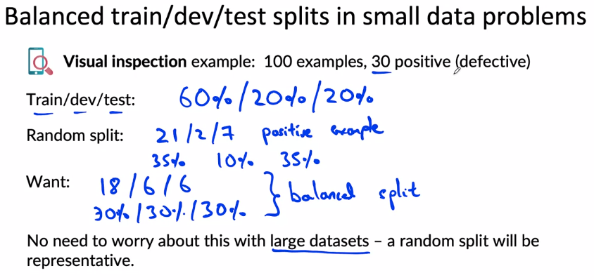

### Scoping (optional)

#### What is scoping?

I find that if you buy yourself or your team is going to spend a lot of time, weeks or months or even longer work on the project is well worth your while to think through a few options and try to select the most promising project to work on before putting so much effort into it.

What I've seen in a lot of businesses is that of all the ideas you can work on, some are going to be much more valuable than others. Maybe two times or five times or 10 times more valuable than a different idea. And being able to pick the most valuable project will significantly increase the impact of your work.

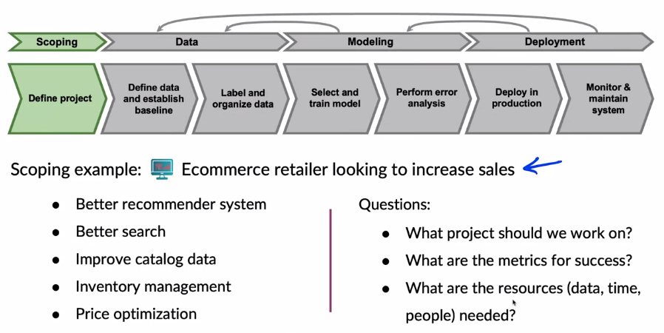

#### Scoping process

The first thing I do is usually get together with a business or private owner. Often not an Ai person, but someone that understands the business and application and to brainstorm with them. What are their business or application problems? And at this stage I'm trying to identify a business problem, not an Ai problem.

I find it is hopeful for this process to separate out the identification of the problem, from the identification of the solution as engineers. We are pretty good at coming up with solutions, but having a clear articulation of what is the problem first often helps us come up with better solutions.

After brainstorming a variety of different solutions, I would then assess the feasibility and the value of these different solutions. Sometimes you hear me use the word **diligence**, to refer to this phrase.

After validating technical feasibility and value or ROI. Return on investment if you can project if it still looks promising right, if it still looks promising. We then flesh out the milestones for the project and finally budget for resources.

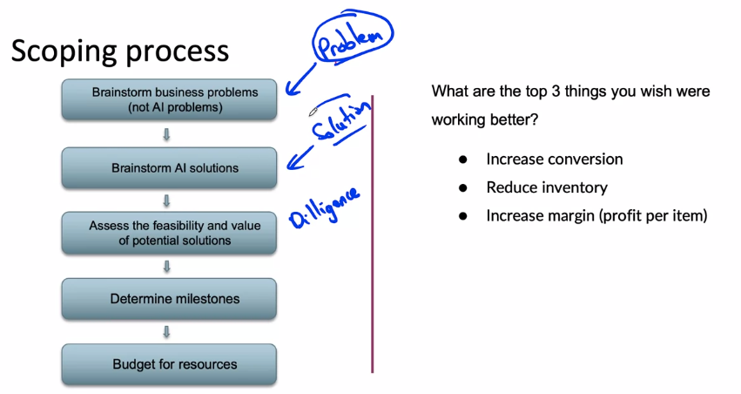

The problem identification is a step of thinking through whether the things you want to achieve. And solution identification is a process of thinking through how to achieve those objectives.

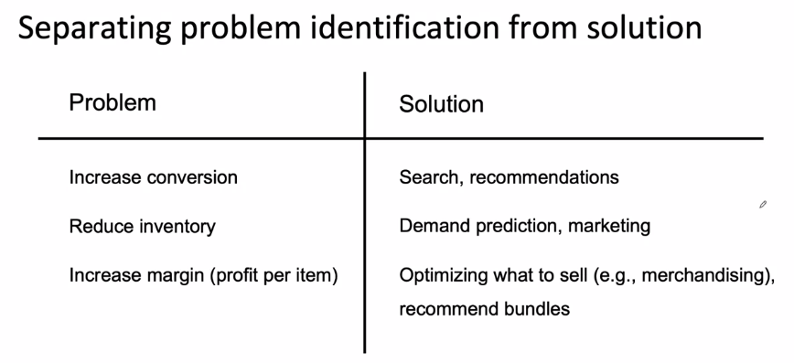

#### Diligence on feasibility and value

New means you are delivering a brand new capability and the existing means you're scoping out the project to improve on an existing capability.

When evaluating HLP, I would give a human the same data as would be fed to a learning algorithm and just ask, can a human given the same data, perform the tasks such as can the human given a picture of a scratch smartphone, perform the task of detecting scratches reliably? If a human can do it, then that significantly increases the hope they can also get the learning algorithm to do it. For existing projects, I would use HLP as a reference as well. Where if you have a visual inspection system and you're hoping to improve it to a certain level of performance. If humans can achieve the level you're hoping to get to, then that might give you more hope that it is technically feasible. Whereas if you're hoping to increase performance well beyond human level performance, then that suggests the project might be harder or may not be possible. In addition to HLP, I often also use the history of the project as a predictor for future progress.

Moving over to the right column. If you're working on a brand new project with structure data, the question I would ask is, are predictive features available? Do you have reason to think that the data you have, the inputs X are strongly predictive or sufficiently predictive of the target outputs Y? In this box on the lower right, for structured data problems, if you're trying to improve an existing system, one thing that will help a lot is if you can identify new predictive features. Are there features that you aren't yet using but you can identify that could really help predict Y and also by looking at? The history of the project.

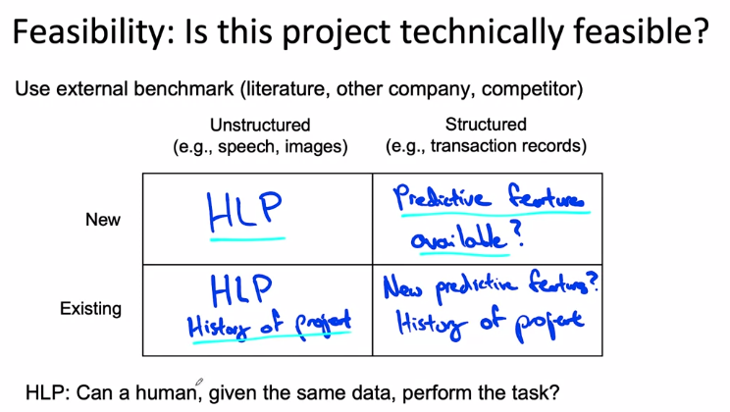

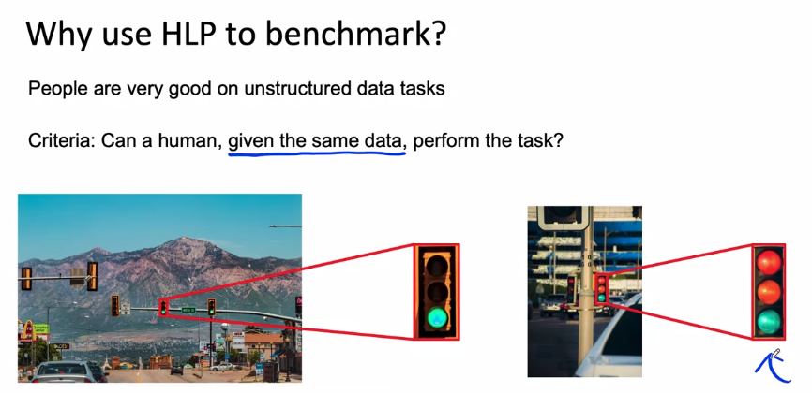

Making sure that a human sees only the same data as a learning algorithm will see is really important. I've seen a lot of projects where for a long time a team was working on a computer vision system, say, and they thought they could do it because a human physically inspecting the cell phone or something could detect the defect. But it took a long time to realize that even a human looking only at the image, couldn't figure out what was going on. If you can realize that earlier, then you can figure much earlier that with the current camera set up, it just wasn't visible. The more efficient thing to do would have been to invest early on in a better camera or better lighting setup or something, rather than keep working on a machine learning algorithm on the problem that I think just wasn't durable, with the imaging setup available at a time.

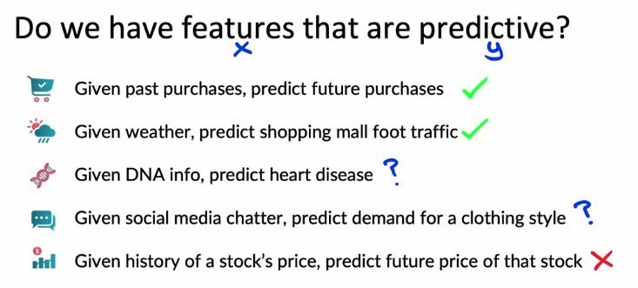

By estimating this rate of progress, you may project into the future that hopefully in future quarters, you continue to reduce the error by 30 percent relative to HRP. This will give you a sense of what might be reasonable for the future rate of progress on this project. This gives you a sense of what may be feasible for an existing project for which you already have this type of history and can try to extrapolate into the future.

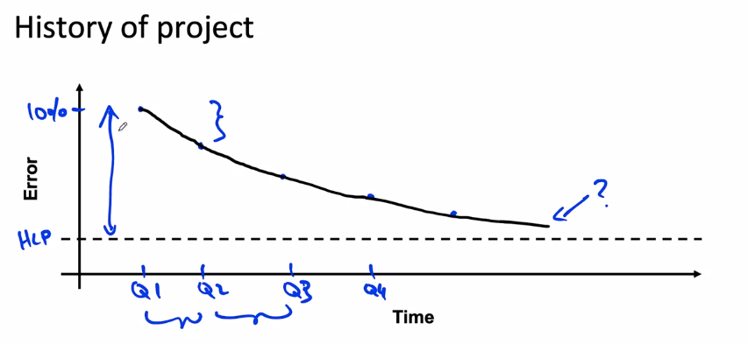

#### Diligence on value

How do you estimate the value of a Machine Learning Project?

The further we go to the right, the harder it is for a machine learning team to really give a guarantee. I wish more problems could be solved by gradient descent or by optimizing tested accuracy. But that's just not to say of the world today, a lot of practical problems require us to do something more than just optimizing tested accuracy.

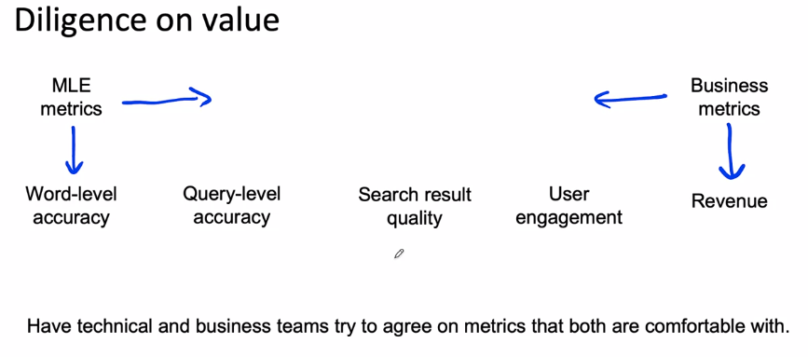

One other practice I've found useful is that you can do even very rough back of the envelope calculations to relate what level of accuracy to some of the metrics on the right. If word accuracy improves by one percent, if you have any rough guess for will that improve query level accuracy, maybe by 0.7 percent or 0.8 percent, and how much will that improve search result quality and user engagement and maybe revenue, if able to come up with even a very crude back of the envelope calculation. Sometimes these are also called **Fermi estimates**.

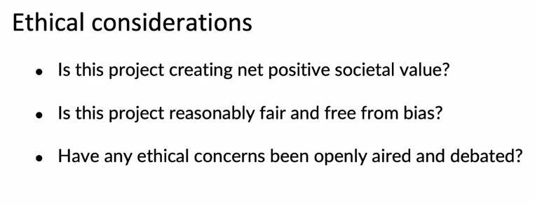

#### Milestones and resourcing

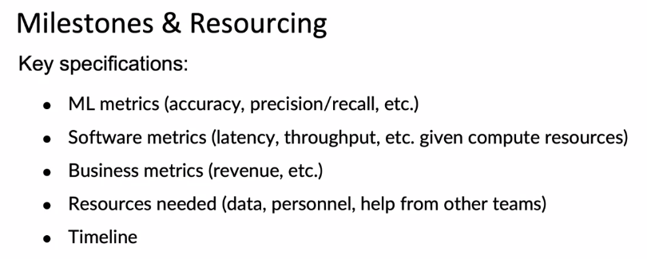

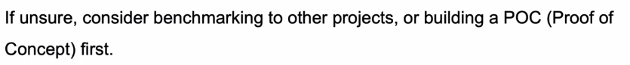

### 

### 

### Week 3 Optional References

### Week 3: Data Definition and Baseline

If you wish to dive more deeply into the topics covered this week, feel free to check out these optional references. You won’t have to read these to complete this week’s practice quizzes.

[Label ambiguity](https://csgaobb.github.io/Projects/DLDL.html)

[Data pipelines](https://cs230.stanford.edu/blog/datapipeline/#best-practices)

[Data lineage](https://blog.tensorflow.org/2021/01/ml-metadata-version-control-for-ml.html)

[MLops](https://cloud.google.com/blog/products/ai-machine-learning/key-requirements-for-an-mlops-foundation)

Geirhos, R., Janssen, D. H. J., Schutt, H. H., Rauber, J., Bethge, M., & Wichmann, F. A. (n.d.). Comparing deep neural networks against humans: object recognition when the signal gets weaker∗. Retrieved May 7, 2021, from Arxiv.org website:<https://arxiv.org/pdf/1706.06969.pdf>

## 

## 

## **References**

Introduction to Machine Learning in Production

This is a compilation of resources including URLs and papers appearing in lecture videos.

Overall resources:

Konstantinos, Katsiapis, Karmarkar, A., Altay, A., Zaks, A., Polyzotis, N., … Li, Z. (2020). Towards ML Engineering: A brief history of TensorFlow Extended (TFX).<http://arxiv.org/abs/2010.02013>

Paleyes, A., Urma, R.-G., & Lawrence, N. D. (2020). Challenges in deploying machine learning: A survey of case studies.<http://arxiv.org/abs/2011.09926>